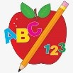 Primary 1 Homework
Week Beginning: 23rd February 2026

Please bring book bags to school every day. They will be collected in on a Friday as there will not be any homework at the weekend. If you feel you want to continue some of the homework over the weekend, please ask for your child’s book bag.

 | Literacy | Numeracy
 | Phonics  Your child should now have all 26 letters of the alphabet. Can they put them in alphabetical order? Do they know the sounds and names of all the letters?  We are now learning what happens when two letters join to make a new sound. These are called joined phonemes or digraphs. The letter lids for digraphs will be green.  Your child can make words with the new digraph and draw a picture. If they want a challenge they can write a sentence for the word.  This week’s new digraph is sh  Common Words  Each week your child will be given common words to read and spell.  There are ideas to help your child to read and spell their common words in their book bag. Orange words are new words for this week’s learning. Green words are those your child should know. Some children may need to keep practising the green words for consolidation.  Any evidence can be put in their Homework jotter eg. Photos, pictures, writing and comments.  New words  she come from  Keep scrolling down  Group 1  I a at the is it an at and  Group 2  am did me as he into my we can  Group 3  go got get if for on be but you  Group 4  was went his to have just only by your  not dad are  This is now group 1, 2, 3 and 4 words completed in class. Children will have word walls in their bookbag. Please keep these safe and revisit often to check reading and spelling.  Reading Book  Children will have reading books in their book bag which they can read to family and friends. Please check book bags each night as they can only keep them for a couple of nights.    Most children have started to explore Hairy Reading on Nessy at home. I hope you are enjoying it and finding it worthwhile. | Most children have started to explore Number Sense on Nessy at home. I hope you are enjoying it and finding it worthwhile.  In class we are learning about time. This starts with seasons, days of the week and months of the year.  Ask your child to recite these in order and then ask them what comes before or after a particular season day or month.  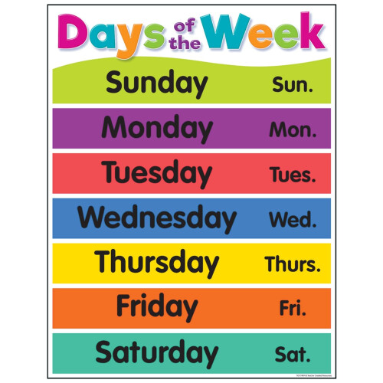
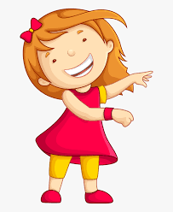Remember to have lots of fun! 