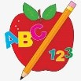 Primary 1 Homework
Week Beginning: 11th February 2026

This homework is for two weeks due to be handed in on Friday 20th February as first week is only 3 days

Please bring book bags to school every day. They will be collected in on a Friday as there will not be any homework at the weekend. If you feel you want to continue some of the homework over the weekend, please ask for your child’s book bag.

 | Literacy | Numeracy
 | Phonics  Each week your child will get new letters in the form of milk bottle lids. Vowels are red and consonants are blue. They need to know the letter sound, name and write the letter correctly. At this stage this may be all your child can manage. Letters can be written in homework jotters using coloured pencils, pen, Mummy’s special pen (anything to encourage them to write).  Challenge  In class we have been trying to make, read and write words with the letters we have learned using magnetic letters. The children are trying very hard with this and can continue to do it at home with their milk bottle lid letters. This is called blending and can be quite tricky to begin with.  The letters that should be in their book bag are –  a t s m i n p m r d e c k g l f o b u h w j v y z  New Letters is are x and q  Your child should now have all 26 letters of the alphabet. Can they put them in alphabetical order? Do they know the sounds and names of all the letters?  Keep scrolling down  Each week your child will be given common words to read and spell.  There are ideas to help your child to read and spell their common words in their book bag. Orange words are new words for this week’s learning. Green words are those your child should know. Some children may need to keep practising the green words for consolidation.  Any evidence can be put in their Homework jotter eg. Photos, pictures, writing and comments.  New words  not dad are  Group 1  I a at the is it an at and  Group 2  am did me as he into my we can  Group 3  go got get if for on be but you  Group 4  was went his to have just only by your  This is now group 1, 2, 3 and 4 words completed in class. Children will have word walls in their bookbag. Please keep these safe and revisit often to check reading and spelling.  Reading Book  Children will have reading books in their book bag which they can read to family and friends. Please check book bags each night as they can only keep them for a couple of nights.   | We have been learning the strategy that tells us if we add 0 the quantity stays the same. Ask your child some quick add 0 calculations eg. 0+7= or 5+0=  We have been learning the strategy that tells us if you + 1 you go to the next number. Ask your child some quick + 1 calculations eg. 4+1 =  1+ 6=  We have also been learning about doubles. Ask your child some doubles. You can say double 2 or 2+2=  Play the game below if you wish.  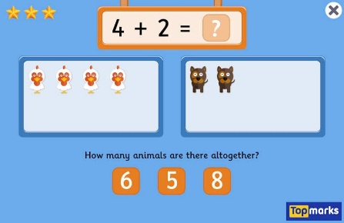  QR CODE  Scan this on mobiles and tablets to quickly open this web page.  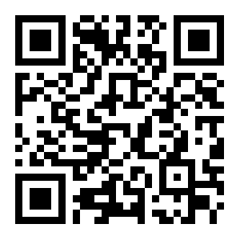
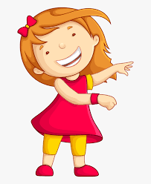Remember to have lots of fun! 