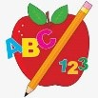 Primary 1 Homework
Week Beginning: 5th January 2026

I hope you have all had a lovely holiday and wish you all the best for the year ahead. Below is the homework for this week, you may find your child will need a bit of revision with all sounds and words as they can get a bit forgetful after a holiday.

 | Literacy | Numeracy
 | Phonics  Each week your child will get new letters in the form of milk bottle lids. Vowels are red and consonants are blue. They need to know the letter sound, name and write the letter correctly. At this stage this may be all your child can manage. Letters can be written in homework jotters using coloured pencils, pen, Mummy’s special pen (anything to encourage them to write).  Challenge  In class we have been trying to make, read and write words with the letters we have learned using magnetic letters. The children are trying very hard with this and can continue to do it at home with their milk bottle lid letters. This is called blending and can be quite tricky to begin with.  The letters that should be in their book bag are –  a t s m i n p m r d e c k g l f o  New Letter is b  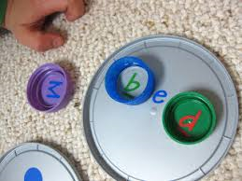  Keep scrolling down  Each week your child will be given common words to read and spell.  There are ideas to help your child to read and spell their common words in their book bag. Orange words are new words for this week’s learning. Green words are those your child should know. Some children may need to keep practising the green words for consolidation.  Any evidence can be put in their Homework jotter eg. Photos, pictures, writing and comments.  This week’s words  be but you  Group 3 word walls in bookbags.  Group 1  I a at the is it an at and  Group 2  am did me as he into my we can  Group 3  go got get if for on  This is now group 1,2 and 3 words completed in class. The children will have word walls in their bookbag. Please keep these safe and revisit often to check reading and spelling.  Reading Book  Some children will have reading books in their book bag which they can read to family and friends. Please check book bags each night as they can only keep them for a couple of nights.  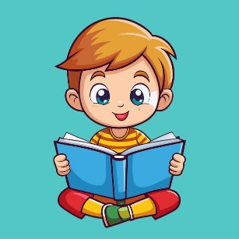 | Numbers to 20  The children are now exploring numbers to 20. If your child is still having difficulty with numbers to 5 or 10 keep practising these.  To be successful the children should be able to…  Count forwards to 20  Count backwards from 20  Recognise and write numbers to 20  Recognise number words to 20  Count objects to 20  Try the game below. Click on QR code.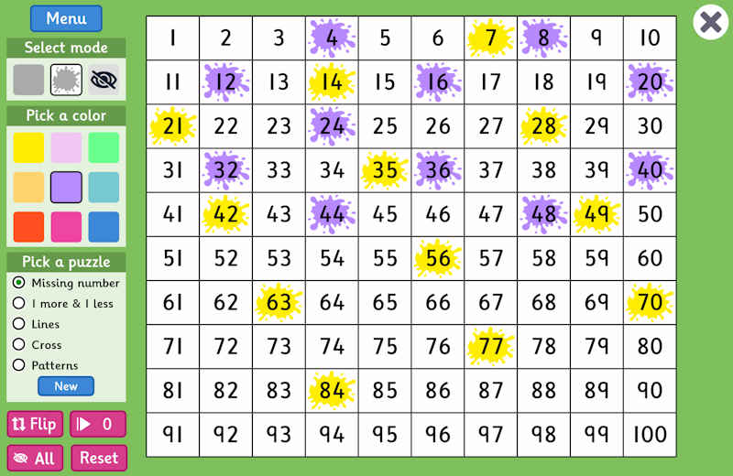  QR CODE  Scan this on mobiles and tablets to quickly open this web page.  
Keep Scrolling

If your child is writing, please encourage them to hold their pencil correctly.

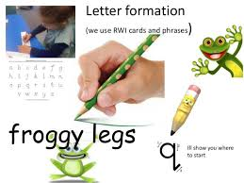
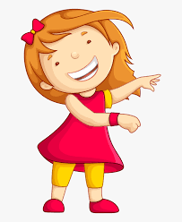Remember to have lots of fun! 