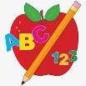 Primary 1 Homework
Week Beginning: 15 th December 2025
No homework for this week I hope you and your family have a lovely Christmas.
Top marks have some fun games for Christmas. I have posted one below but there are more on the site.
Keep a check on the photo tab for Nativity and party photos after party.

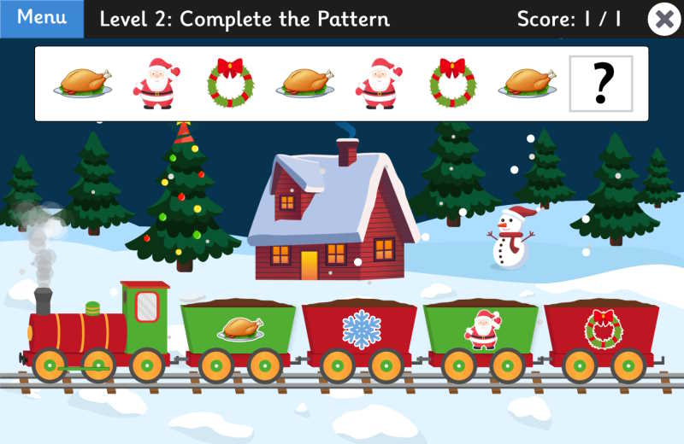
QR CODE
Scan this on mobiles and tablets to quickly open this web page.

Enjoy some Christmas pattern fun.

