**Week Beginning: 21st October 2025**

I hope you all had a lovely break. We will start back gently with the homework. Do what you can and please try to keep it fun, if homework is a struggle just leave it.

Please check your child’s bookbag for any new letters or reading books.

|  |  |  |
| --- | --- | --- |
|  | Literacy | Numeracy |
|  | Letter lids in book bag  s a t i p n r m  Please go over all letter sounds with your child and if they can write them correctly in their homework jotter that would be great.  Make words for your child to sound out and read and say words for your child to make. They can write them if they want but if this is proving difficult just write a little note saying you did it all practically.  No new words this week.  **Reading Book**  Some children will have reading books in their book bag which they can read to family and friends. Please check book bags each night as they can only keep them for a couple of nights.  Original | Scan the QR code below to play the game.      Teddy Numbers |
|  | **If your child is writing, please encourage them to hold their pencil correctly.**    C:\Users\dronprbradyj\AppData\Local\Microsoft\Windows\INetCache\Content.MSO\69D64E15.tmp |  |

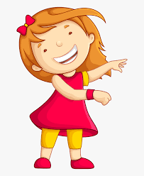Remember to have lots of fun!   