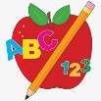 Primary 1 Homework
Week Beginning: 24th March 2025
Here is a guide to help you for this week. You can choose how to organise your tasks to suit what works for you.
Please bring book bags to school every day. They will be collected in on a Friday as there will not be any homework at the weekend.
 | Literacy | Numeracy
 | Phonics  This week’s new joined phoneme / digraph is ph.  There are not many sounding out words with ph but your child could make: dolphin, graph, phonics.  Common Words  Group 6 word wall in book bags.  New words – new little one  Continue to work on previous words should your child still need to practise reading/spelling them.  Words the children should now know –  Group 1 – a at the I is it an and in  Group 2 – am he me did as we my can into  Group 3 – go got get if for on be but you  Group 4 – was went his have just to your by only dad are not  Group 5 – she come from this that then with us so much of or  Group 6  old do going out now first  Traffic Light words  The green words are for go – your children should know  these words.  Reading  Your child may bring a reading book home. Please encourage them to point to the words as they read.   | Consolidation of subtraction and addition.  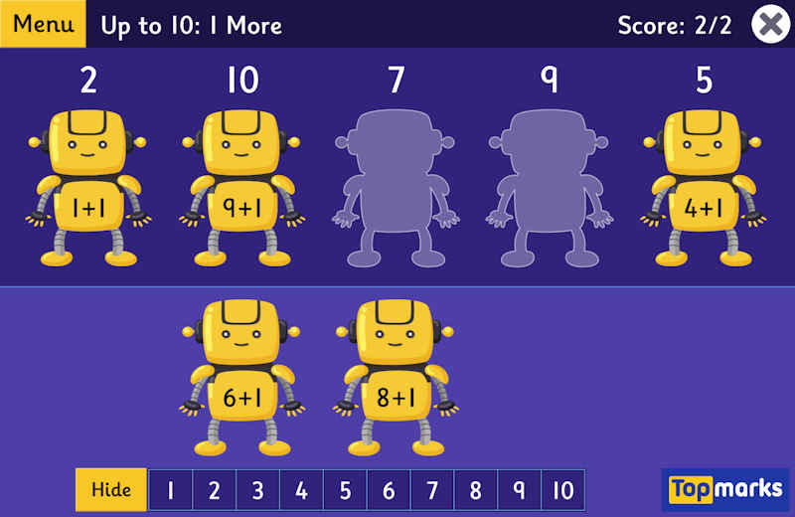  QR CODE  Scan this on mobiles and tablets to quickly open this web page.  