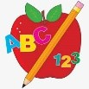**Primary 1 Homework** 

**Week Beginning: 28th October 2024**

Here is a guide to help you for this week.  You can choose how to organise your tasks to suit what works for you.

Please bring book bags to school every day.  They will be collected in on a Friday as there will not be any homework at the weekend.  If you feel you want to continue some of the homework over the weekend, please ask for your child’s book bag.

|  |  |  |
| --- | --- | --- |
|  | Literacy | Numeracy |
|  | **Phonics**    Each week your child will get new letters in the form of milk bottle lids.  Vowels are red and consonants are blue.  They need to know the letter sound, name and write the letter correctly.   They should try to make, read and write words with the letter lids in their book bag.  This is called blending and can be quite tricky to begin with.    The letters that should be in their book bag are –  a t s i m n p c k r o    The focus is to blend the letters to read and write words.  Most children should be able to make three letter words but if your child needs a challenge try four/five letter words that can be sounded out.  Eg spit, pant, stamp, mint, mist. | **Numbers to 10**    Click on the Topmarks icon on the class blog page and type Underwater Counting.  Most children should be able to work with numbers to 10 but if your child finds this tricky work with numbers to 5.  C:\Users\dronprbradyj\AppData\Local\Microsoft\Windows\INetCache\Content.MSO\E6C9FE5C.tmp |
|  | **Common Words**   We have now completed group 1 common words. Most children are confident reading the words but may need a little more time practising spelling them correctly.  This week’s words –                   he am me    Words the children should now know –  **Group 1** – a  at  the  I  is  it an and in    **Traffic Light words**  The green words are for go – your children should know these words. The orange words are for get ready – your children are practising these.  **Reading Book**  Some children will have reading books in their book bag which they can read to family and friends.  Original |  |

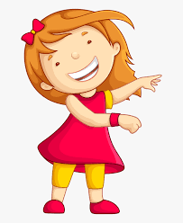Remember to have lots of fun!   