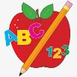Primary 1 Homework
Week Beginning: 15th April 2024
Here is a guide to help you for this week. You can choose how to organise your tasks to suit what works for you.
Please bring book bags to school every day.
 | Literacy | Numeracy
 | Phonics  We have learned a new joined phoneme (digraph) – ch.  Use the letter lids to make as many words as you can. You can draw pictures for the words if you wish.  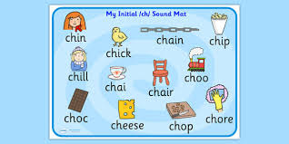 | Addition to 10  We are learning about addition to 10. Click on the link below to play Hit the Button. Click on Number Bonds and Addition up to 10.  https://www.topmarks.co.uk/maths-games/hit-the-button  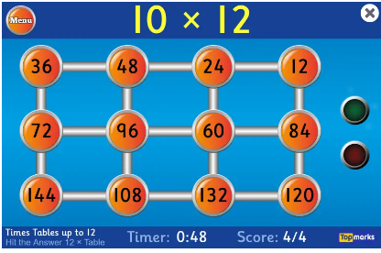
Common Words

New words – with us so much of or

Continue to work on previous words should your child still need to practise reading/spelling them.
Group 1 – a at the I is it an and in
Group 2 – am as me did he we my can into
Group 3 – go got get if for on be but you
Group 4 – was went his have just to your by only dad are not
Group 5 - she come from this that then

Reading

Your child may bring a reading book home. Please encourage them to point to the words as they read.

