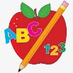Primary 1 Homework
Week Beginning: 18th March 2024
Here is a guide to help you for this week. You can choose how to organise your tasks to suit what works for you.
Please bring book bags to school every day.
 | Literacy | Numeracy
 | Phonics  We have learned a new joined phoneme (digraph) th. This makes a hard sound as in “then” and a soft sound as in “thin”’  Use the letter lids to make as many words as you can. You can draw pictures for the words if you wish.  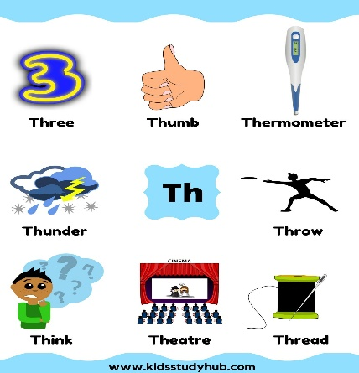 | Addition to 10  We are learning strategies to add numbers mentally and quickly.  Add 0 the number stays the same.  Add 1 just go to the next number.  Say some add 1 and add 0 calculations to your child and see how quickly they can answer.  Play the game below with a focus on add 1 and add 0.  https://www.topmarks.co.uk/addition/robot-addition
Common Words

We have started Group 5 Common Words.

New words – this that then
Continue to work on previous words should your child still need to practise reading/spelling them.
Group 1 – a at the I is it an and in
Group 2 – am as me did he we my can into
Group 3 – go got get if for on be but you
Group 4 – was went his have just to your by only dad are not
Group 5 - she come from

Reading

Your child may bring a reading book home. Please encourage them to point to the words as they read.

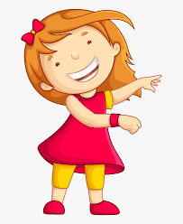Remember to have lots of fun!

