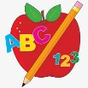Primary 1 Homework
Week Beginning: 11th March 2024
Here is a guide to help you for this week. You can choose how to organise your tasks to suit what works for you.
Please bring book bags to school every day.
 | Literacy | Numeracy
 | Phonics  We are continuing to work on sh.  Click on the link below to play Forest phonics.  Choose sh.  https://ictgames.com/mobilePage/forestPhonics/index.html  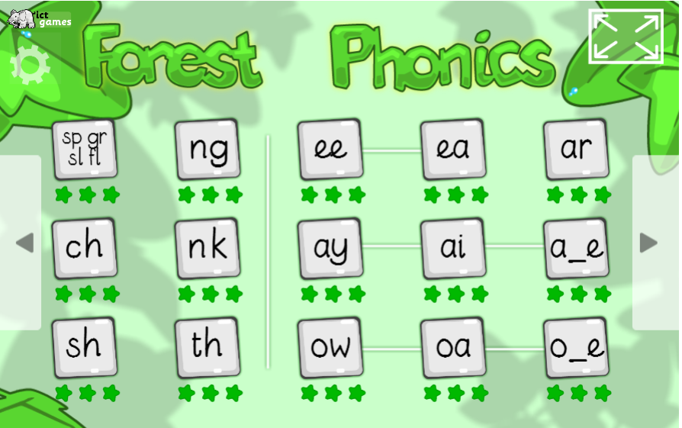 | Addition to 10  We are now learning about addition to 10. Click on the link below to play Robot Addition.  https://www.topmarks.co.uk/addition/robot-addition
Common Words

We have started Group 5 Common Words.

New words – she come from

Continue to work on previous words should your child still need to practise reading/spelling them.
Group 1 – a at the I is it an and in
Group 2 – am as me did he we my can into
Group 3 – go got get if for on be but you
Group 4 – was went his have just to your by only dad are not

Reading

Your child may bring a reading book home. Please encourage them to point to the words as they read.

Remember to have lots of fun!

