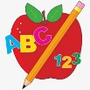Primary 1 Homework
Week Beginning: 4th March 2024
Here is a guide to help you for this week. You can choose how to organise your tasks to suit what works for you.
Please bring book bags to school every day.
 | Literacy | Numeracy
 | Phonics  Your child should now have all the letters of the alphabet. If there are any missing letters let us know and we will replace them.  This week we met a new joined phoneme (digraph).  This is when two letters come together to make one sound.  This week’s new joined phoneme is sh.  Your child has a green letter lid with sh on it. Try to make as many words as you can with sh at the beginning, middle or end.  You can choose to draw a picture for the word or write a sentence.  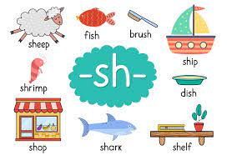 | Addition to 10  We are now learning about addition to 10. Click on the link below.  https://www.topmarks.co.uk/addition/addition-to-10  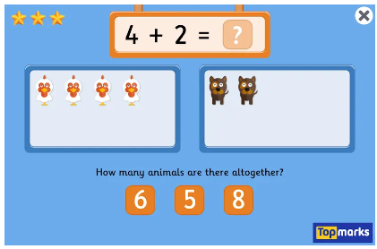
Reading

Your child may bring a reading book home. Please encourage them to point to the words as they read.

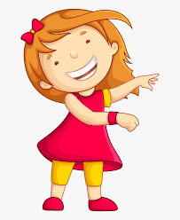Remember to have lots of fun!

