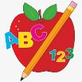Primary 1 Homework
Week Beginning: 26th February 2024
Here is a guide to help you for this week. You can choose how to organise your tasks to suit what works for you.
Please bring book bags to school every day.
 | Literacy | Numeracy
 | Phonics  Your child should now have all the letters of the alphabet. Encourage them to put the letter lids in alphabetical order and say the letter sounds and names.  You will notice they now have a green letter lid. This is called a digraph or joined phoneme. It is the sound make when two letters come together. Encourage your child to make words with the joined phoneme qu. Eg. quiz, quit, quilt, squid, quid.  New sounds this week – q qu  Your child should now have all the letters of the alphabet. If they have any missing letters let us know and we will replace them.  Group 1 - a t s i n p  Group 2 – m r d e c k  Group 3 – g l f o b u  Group 4 – h w j v y z  Group 5 – x q qu | Pictogram  Click on the link below to play the pictogram game.  https://toytheater.com/fruit-fall/  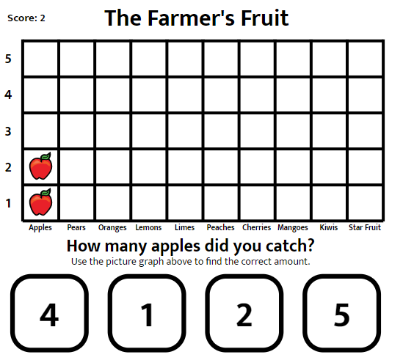
Common Words

We have completed Group 4 words.

This is an assessment week to test the reading and spelling of the words. Continue to practise these at home.

Words the children should now know –
Group 1 – a at the I is it an and in
Group 2 – am as me did he we my can into
Group 3 – go got get if for on be but you
Group 4 – was went his have just to your by only dad are not

Reading

Your child may bring a reading book home. Please encourage them to point to the words as they read.

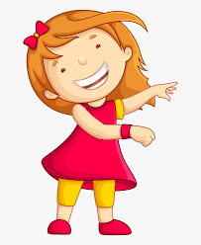Remember to have lots of fun! 