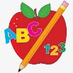Primary 1 Homework
Week Beginning: 14th February 2024

No written homework as this is a short week. Your child may get a reading book and they can revise all letter lids and word walls.

