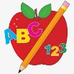Primary 1 Homework
Week Beginning: 5th February 2024
Here is a guide to help you for this week. You can choose how to organise your tasks to suit what works for you.
Please bring book bags to school every day.
 | Literacy | Numeracy
 | Phonics  Each week your child will get new letters in the form of milk bottle lids. Vowels are red and consonants are blue. They need to know the letter sound, name and write the letter correctly. They should try to make, read and write words with the sounds in their book bag. This is called blending and can be quite tricky to begin with.  New sounds this week – y  The letters that should be in their book bag are –  Group 1 - a t s i n p  Group 2 – m r d e c k  Group 3 – g l f o b u  Group 4 – h w j v y  The focus is to blend the letters to read and write words. Most children should be able to make three letter words but if your child needs a challenge try four/five letter words that can be sounded out.  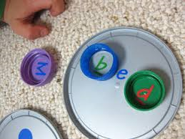  Below is a video below for you to watch to help support your child with blending.  https://watchkin.com/ce7676932f | Time  We have been exploring o’clock times.  Remind your child that it is only an o’clock time if the long hand is on the 12.  Click on the link below and choose Level 1.  https://mathsframe.co.uk/en/resources/resource/116/telling-the-time  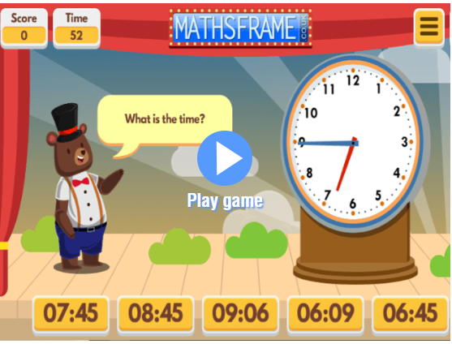
Common Words

We have now moved onto Group 4 words. This week’s words are –
your by only

As we start the new year most children are confident in reading Groups 1 to 3. They are still finding it a bit tricky to spell these words. This week’s homework is to practise spelling the words written in purple.

Words the children should now know –
Group 1 – a at the I is it an and in
Group 2 – am as me did he we my can into
Group 3 – go got get if for on be but you
Group 4 – was went his have just to

*Group 3 word wall is in your child’s book bag.

Reading

Your child may bring a reading book home. Please encourage them to point to the words as they read.

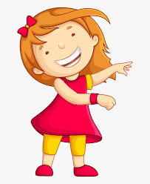Remember to have lots of fun!

