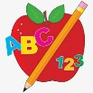 Primary 1 Homework
Week Beginning: 15th January 2024
Here is a guide to help you for this week. You can choose how to organise your tasks to suit what works for you.
Please bring book bags to school every day. They will be collected in on a Friday as there will not be any homework at the weekend. If you feel you want to continue some of the homework over the weekend, please ask for your child’s book bag.
 | Literacy | Numeracy
 | Phonics  Each week your child will get new letters in the form of milk bottle lids. Vowels are red and consonants are blue. They need to know the letter sound, name and write the letter correctly. They should try to make, read and write words with the sounds in their book bag. This is called blending and can be quite tricky to begin with.  New sounds this week – u h  The letters that should be in their book bag are –  Group 1 - a t s i n p  Group 2 – m r d e c k  Group 3 – g l f o b u  Group 4 – h  The focus is to blend the letters to read and write words. Most children should be able to make three letter words but if your child needs a challenge try four/five letter words that can be sounded out.  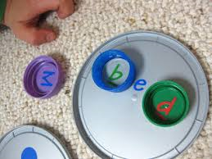  Below is a video below for you to watch to help support your child with blending.  https://watchkin.com/ce7676932f | Time  We are learning about seasons, months and days of the week. This week we will concentrate on months. Below is a song for the children to practise.  https://www.youtube.com/watch?v=Fe9bnYRzFvk  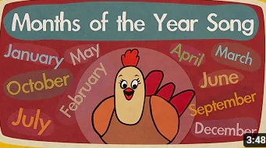  Your child has a calendar in their book bag. Ask how many Tuesdays in February, Mondays in August, etc.
Common Words

As we start the new year most children are confident in reading Groups 1 to 3. They are still finding it a bit tricky to spell these words. This week’s homework is to practise spelling the words written in purple.

Words the children should now know –
Group 1 – a at the I is it an and in
Group 2 – am as me did he we my can into
Group 3 – go got get if for on be but you

*Group 3 word wall is in your child’s book bag.

Reading

Your child may bring a reading book home. Please encourage them to point to the words as they read.

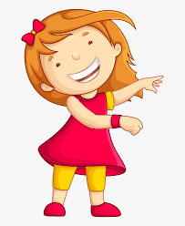Remember to have lots of fun! 