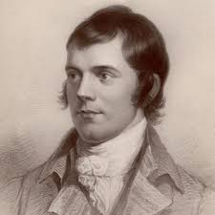 Up in the Morning Early
by Robert Burns

Cauld blaws the wind frae east to west,
The drift is driving sairly;
Sae loud and shrill’s I hear the blast,
I’m sure it’s winter fairly.
Up in the morning’s no for me,
Up in the morning early;
When a’ the hills are cover’d wi’ snaw,
I’m sure its winter fairly.
The birds sit chittering in the thorn,
A’ day they fare but sparely;
And lang’s the night frae e’en to morn,
I’m sure it’s winter fairly.
Up in the morning’s no for me,
Up in the morning early;
When a’ the hills are cover’d wi’ snaw,
I’m sure its winter fairly.

