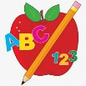 Primary 1 Homework
Week Beginning: 6th November 2023
Here is a guide to help you for this week. You can choose how to organise your tasks to suit what works for you.
Please bring book bags to school every day. They will be collected in on a Friday as there will not be any homework at the weekend. If you feel you want to continue some of the homework over the weekend, please ask for your child’s book bag.
 | Literacy | Numeracy
 | Phonics  Each week your child will get new letters in the form of milk bottle lids. Vowels are red and consonants are blue. They need to know the letter sound, name and write the letter correctly. They should try to make, read and write words with the sounds in their book bag. This is called blending and can be quite tricky to begin with.  New sound this week - d  The letters that should be in their book bag are –  Group 1 - a t s i n p  Group 2 – m r d  The focus is to blend the letters to read and write words. Most children should be able to make three letter words but if your child needs a challenge try four/five letter words that can be sounded out. Eg spit, pant, stamp, mint, mist.  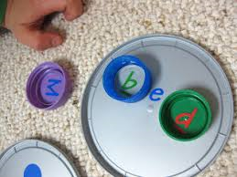  Below is a video below for you to watch to help support your child with blending.  https://watchkin.com/ce7676932f | Numbers to 10  We are working on number words to 10. Please click on the link below.  https://www.sheppardsoftware.com/math/early-math/number-words-fruit-splat-game/  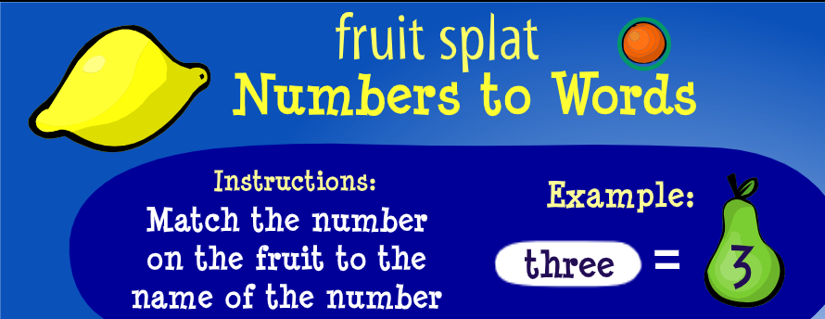
Common Words

Each week your child will be given words to read and spell.
There are activities to help your child to read and spell their common words in their book bag.

Any evidence can be put in their Homework jotter eg. Photos, pictures, writing and comments.

This week’s words –
am as me

Words the children should now know –
Group 1 – a at the I is it an and in

Traffic Light words
The green words are for go – your children should know these words. The orange words are for get ready – your children are practising these.
If you find your child is finding some of the words tricky then tell them to keep practising.

Reading

Your child may bring a reading book home. Please encourage them to point to the words as they read.

