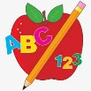 Primary 1 Homework
Week Beginning: 2nd October 2023
Here is a guide to help you for this week. You can choose how to organise your tasks to suit what works for you.
Please bring book bags to school every day. They will be collected in on a Friday as there will not be any homework at the weekend. If you feel you want to continue some of the homework over the weekend, please ask for your child’s book bag.
 | Literacy | Numeracy
 | Phonics  Each week your child will get new letters in the form of milk bottle lids. Vowels are red and consonants are blue. They need to know the letter sound, name and write the letter correctly. They should try to make, read and write words with the sounds in their book bag. This is called blending and can be quite tricky to begin with.  The letters that should be in their book bag are –  a t s i m  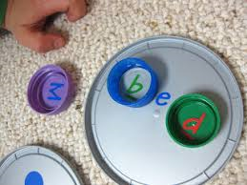  Below is a video below for you to watch to help support your child with blending.  https://watchkin.com/ce7676932f | Numbers to 10  Click on the link below for your child to learn more about numbers to 10.  https://www.youtube.com/watch?v=pzmB0GoEKkA  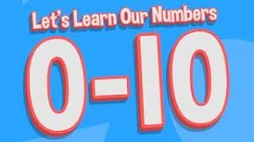
Common Words

Each week your child will be given words to read and spell.
There are activities to help your child to read and spell their common words in their book bag. If you find that Task 4 causes confusion about using capital letters correctly please swap this for Rainbow Writing (writing each letter with a different colour). This list is not prescriptive and the aim is for your child to read and spell their words accurately. If you can find more fun ideas please share with us. Perhaps some outdoor learning using sticks and stones to make the words.

Any evidence can be put in their Homework jotter eg. Photos, pictures, writing and comments.

This week’s words –
a at the

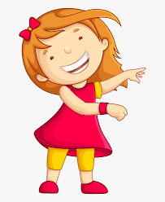Remember to have lots of fun! 