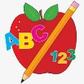 Primary 1 Homework
Week Beginning: 18th September 2023
Here is a guide to help you for this week. You can choose how to organise your tasks to suit what works for you.
Please bring book bags to school every day. They will be collected in on a Friday as there will not be any homework at the weekend. If you feel you want to continue some of the homework over the weekend, please ask for your child’s book bag.
 | Literacy | Numeracy
 | Phonics  Each week your child will get new letters in the form of milk bottle lids. Vowels are red and consonants are blue. They need to know the letter sound, name and write the letter correctly. They should try to make, read and write words with the sounds in their book bag. This is called blending and can be quite tricky to begin with.  The letters that should be in their book bag are –  a t s  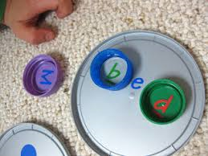  Below is a video below for you to watch to help support your child with blending.  https://watchkin.com/ce7676932f | Your child will have number cards in their book bag. Ask your child to put the cards in order from 0 – 10 and 10 – 0. Ask questions like what comes before, after and in-between a certain number/numbers.  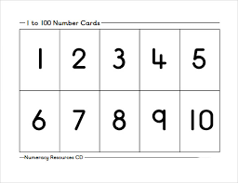
If your child is drawing/colouring, please encourage them to hold their pencil correctly.

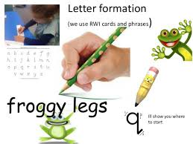
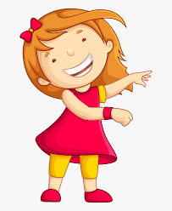Remember to have lots of fun! 