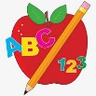 Primary 1 Homework
Week Beginning: 11th September 2023
Here is a guide to help you for this week. You can choose how to organise your tasks to suit what works for you.
Please bring book bags to school every day. They will be collected in on a Friday as there will not be any homework at the weekend. If you feel you want to continue some of the homework over the weekend, please ask for your child’s book bag.
 | Literacy | Numeracy
 | We have been working on syllables in class. Syllables are parts of a word.  Clap out the names of your family in syllables: eg.  Lin-da  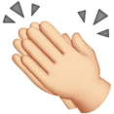  2 syllables  Chris-to-pher  3 syllables  James  1 syllable | Your child will have number cards in their book bag. Play the game Splat. Place the cards randomly on the floor. Call out a number and your child should splat it with a spoon. If your child is finding recognising all the numbers tricky, reduce the number of cards. If your child finds recognising the numbers easy, challenge them by clapping your hands and getting them to splat the number.  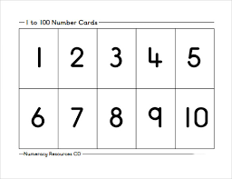
If your child is drawing/colouring, please encourage them to hold their pencil correctly.

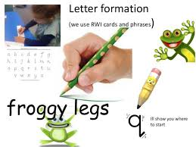
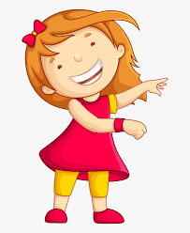Remember to have lots of fun! 