P7 Homework – 16th February 2026

Spelling:
LI- To be able to say and spell “y” words accurately

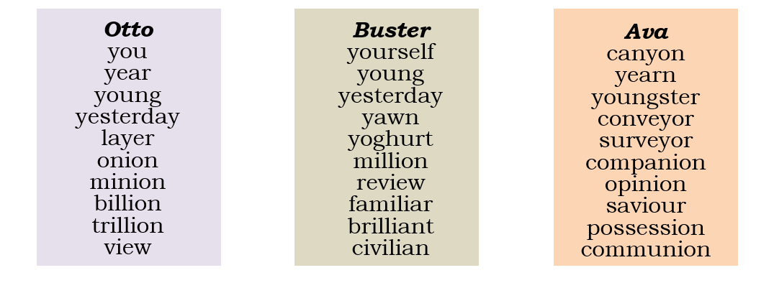
LCWC (3) and then choose 1 activity from the sheet to complete – different one from last week.

Maths:
LI1- To be able to develop my accuracy in using different operations
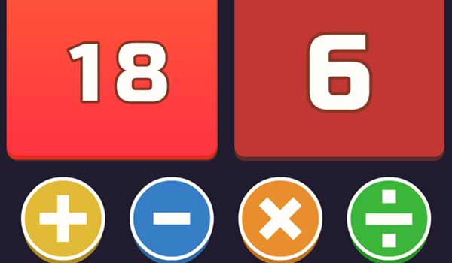

Go and play the 24 game on coolmathsgames! See what you can get as your best streak without getting help!

Reading/Talking:
LI- To be able to find the meaning of unfamiliar words

Our new novel for class is Divided City. There are many different themes that we will focus on in class. However, before we do so, it would be good to understand the meaning of some of the themes, as well as the key words that will pop up.

Your task is to first predict what you think the word means and then find the actual meaning using a dictionary.

Word list:
division, border, community, conflict, identity, barrier, segregation, peace, sectarianism, tolerance

Example:

“sectarianism” – I predict this word means….

The actual meaning “sectarianism” is ….

