P7A Homework – 19th January 2026

Spelling:

LI- To be able to say and spell “t” words accurately

Otto: getting, shatter, together, liked, putting, taste, pizza, wished, tried, teacher

Buster: triangle, treasure, tomato, trousers, splatter, bottle, taste, route, gripped, pizza

Ava: terrifying, territory, lettuce, attraction, baguette, palette, receipt, pterodactyl, debt, pizzicato

LCWC (3) and then choose 1 activity from the sheet to complete – different one from last week.

Maths:

LI- To be able to identify equivalent fractions

Complete one of the equivalent fractions worksheets attached. Choose your own level and try and challenge yourself.

Reading/Talking:

LI- To be able to develop my accuracy and fluency in reciting poetry

Rehearse Burn’s Poem – Tam O’ Shanter
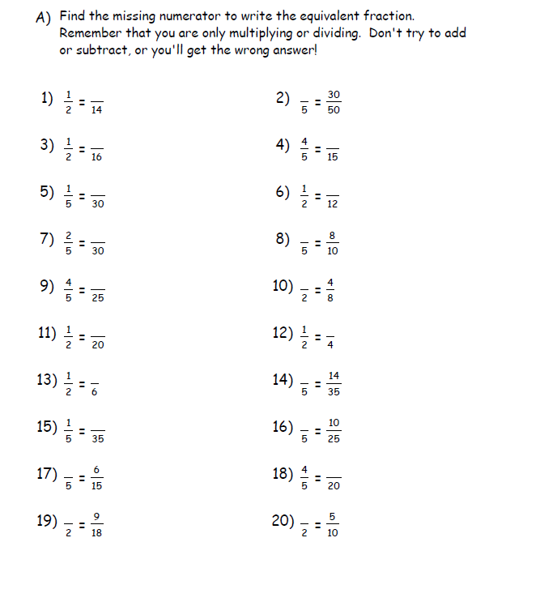
All:

Some:
