Primary 6 Homework Overview 26/02/24

We are going digital! Please access this homework sheet on the school blog. https://blogs.glowscotland.org.uk/ea/mrsmitchell/homework/
If there are any issues accessing the blog, your teacher will issue a homework sheet. This is to reduce waste and costs. Thanks.
Spelling
Spelling: ‘oi’
Copy your spelling words three times in your jotter, then complete this week’s spelling activity;
connectives

Copy and complete these sentences:

1. Our sea voyage was unavoidably delayed but…
2. Our sea voyage was unavoidably delayed while…
3. Our sea voyage was unavoidably delayed despite…
4. Our sea voyage was unavoidably delayed while…

Red | Yellow | Green
oil  boil  spoil  toy  boy | avoid  rejoin  moisture  appoint  disappoint  enjoyment  destroy  employ  loyal  annoying | moisturiser  appointment  disappoint  disappointment  unavoidable  employment  voyage  buoy  disloyal  boycott

Numeracy and Mathematics

Converting Length: ‘mm to cm’

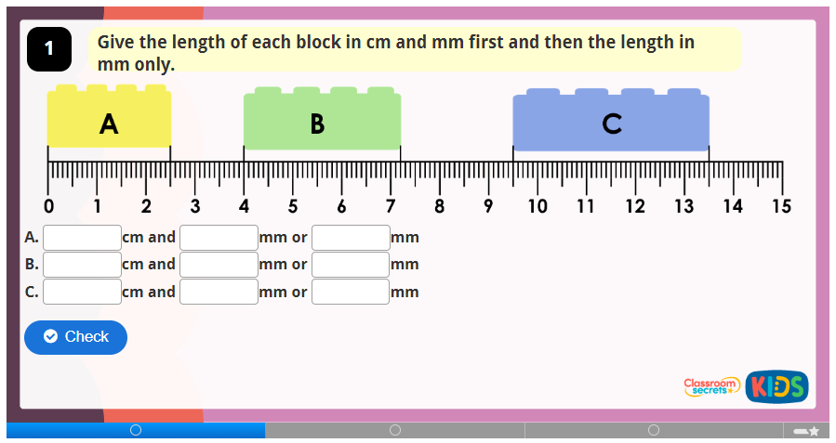

https://kids.classroomsecrets.co.uk/resource/year-3-equivalent-lengths-mm-and-cm-game/


