REF: DF/ZS
Date: 11.12.23

To: Head Teachers all Primary, Secondary and Special Schools
PT of Physical Education and Private Dance Schools and Groups

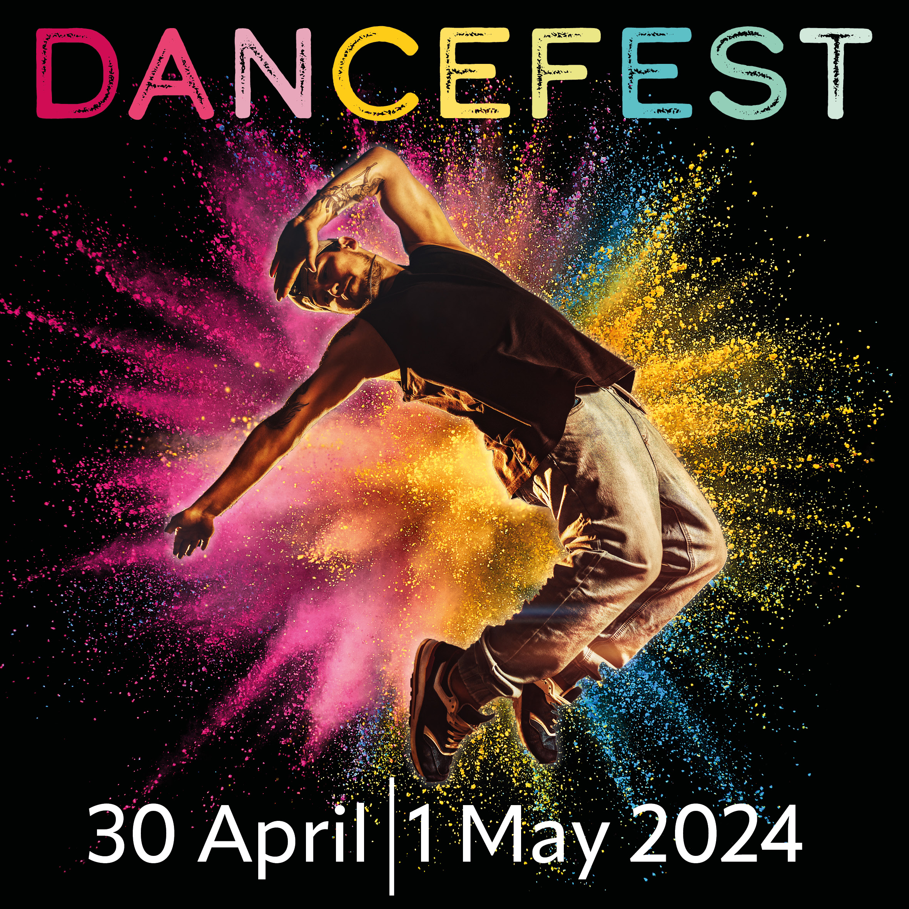
Dear Colleague,

,
DANCE FEST 2024
The Gaiety, Ayr 30 April/ 1 May

We are now in the process of gathering entries for Dance Fest 2024. East Ayrshire’s Dance Fest is the largest, most successful celebration of dance across Ayrshire. Don’t miss out on taking part in 2024! This exciting Dance Festival will take place in The Gaiety, Ayr Tuesday 30th April and Wednesday 1st May and will showcase Ayrshire’s best dance talent. Tickets for family and friends will be available nearer the time from the box office.

Please note: Due to the Palace closure, this year’s show will be in The Gaiety, Ayr.

We are looking for acts to perform a dance routine on one of the above nights. If you have a group(s)/soloist you think would like to apply then please complete the enclosed Application Form and return to me via email to zara.smith1@eastayrshire.org.uk by Friday 19th January 2024.

If you have any questions please email zara.smith1@eastayrshire.org.uk

Yours sincerely

Z.Smith

Zara Smith
Cultural Coordinator, Dance & Movement
Creative Minds Team

Encs

Dance Fest 2024@ The Gaiety, Ayr

APPLICATION FORM

Dance Fest 2024 returns this 30 April/ 1 May for its 13th year as Ayrshire’s largest Dance Festival.
If you would like to take part in Dance Fest 2024 please complete and return this application form by 19 January 2024.

Organisation/School Name
Dance Group/Stage Name
(If different from above)
Organisation/School Address
Main Contact – Name and Job Title:
Tel (day)
Email

About your Group:

Style of Dance
Intended Songs
(please be as accurate as you can to ensure no duplication of songs will occur)
Anticipated length of routine (in minutes)
Anticipated number of participants
Anticipated age range of participants
Any disabled access requirements to the stage
Please tell us a little bit about your group

Declaration:
I understand that, if successful, there will be further contractual notes which I shall be asked to sign in agreement including numbers of dancers, standards of behaviour, and a requirement for choreography, costume and music to be acceptable for a family audience.

Signed
Print Name
Date

Please return all completed forms to: zara.smith1@eastayrshire.org.uk
Please Note: We cannot guarantee places for all those interested in taking part in Dance Fest 2024, although we will do our best to include everyone, The Creative Minds will have final say on the programme.

