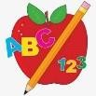 Primary 3/4 Homework
Week Beginning: 27th October 2025
Here is a guide to help you for this week. You can choose how to organise your tasks to suit what works best for you.

Spelling | Numeracy
Copy your words three times. Then choose an activity from the spelling menu at the back of your jotter.  - Phoneme Words –  - Common Words –  Please revise/practise reading and spelling all of the common words from Stages 1, 2 and 3 (attached below). This will be a huge help for all of your reading and spelling. | Number Bonds to 20  We are revising and practicing number bonds to 10 and 20. What is the highest score you can achieve in the time?  https://www.topmarks.co.uk/maths-games/hit-the-button  Times Tables  We are learning and practicing the times tables.  https://www.timestables.co.uk/  Grid References and Directions  We are learning about grid references and directions.  https://www.scootle.edu.au/ec/viewing/L350/index.html
  Stage 1 | Stage 2 | Stage 3 | Stage 4
  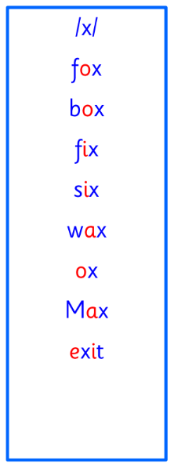 | 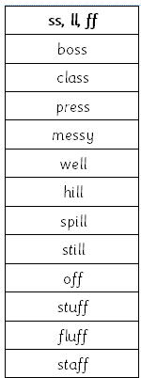 | 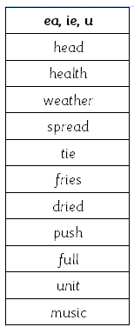 | 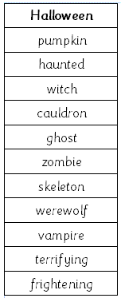
 | Reading
- Your child will get their book home to practise every Monday.
- We will also be practising and completing activities in class so please remember to have their book in their bag every day.


 | PE
P.E. is every Tuesday and Thursday.
Please provide your child with a change of clothing and footwear as well as removing all piercings. If your child has any stud earrings that they can’t
remove, with written permission, we can use plasters to cover them on gym days. Remember your child can leave their PE kit in school which will be kept safely in the classroom.

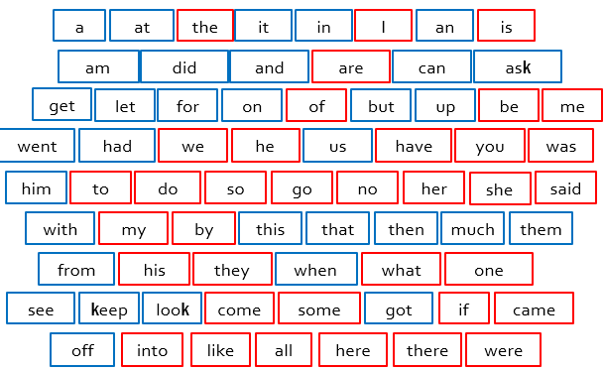
Stage 1

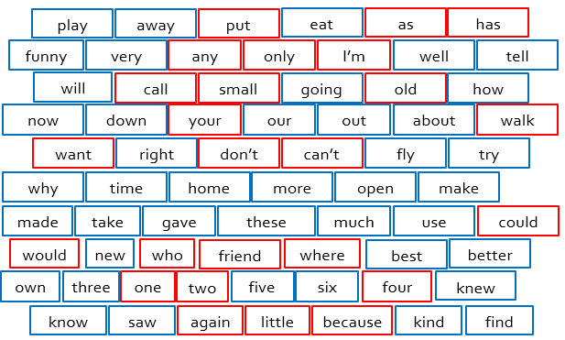
Stage 2

Stage 3
