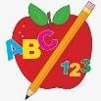 Primary 3/4 Homework 

**Week Beginning: 8th September 2025**

Here is a guide to help you for this week. You can choose how to organise your tasks to suit what works best for you.

|  |  |
| --- | --- |
| **Spelling** | **Numeracy** |
| Copy your words three times. Then choose an activity from the spelling menu at the back of your jotter.   * Phoneme Words –  |  |  |  |  | | --- | --- | --- | --- | | Stage 1 | Stage 2 | Stage 3 | Stage 4 | |  |  |  | argued  massive  plastic  alarming  absconded  aunt  laughing  calm  almond  salmon |  * Common Words –   Please revise/practise reading and spelling all of the common words from Stages 1, 2 and 3 (attached below). This will be a huge help for all of your reading and spelling. | **Number Bonds to 20**  We are revising and practicing number bonds to 10 and 20. What is the highest score you can achieve in the time?  <https://www.topmarks.co.uk/maths-games/hit-the-button>  **Place Value**  We are learning about place value and counting. Have a go at some of these games:  <https://ictgames.com/mobilePage/counting.html>  <https://ictgames.com/mobilePage/placeValue.html> |
| **Reading** |
| * Your child will get their book home to practise every Monday. * We will also be practising and completing activities in class so please remember to have their book in their bag every day. |
| **PE** |
| **P.E. is every Tuesday and Thursday.**  Please provide your child with a change of clothing and footwear as well as removing all piercings. **If your child has any stud earrings that they can’t**  **remove, with written permission, we can use plasters to cover them on gym days**. Remember your child can leave their PE kit in school which will be kept safely in the classroom. |

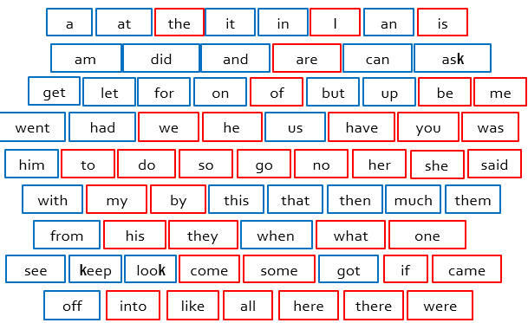Stage 1

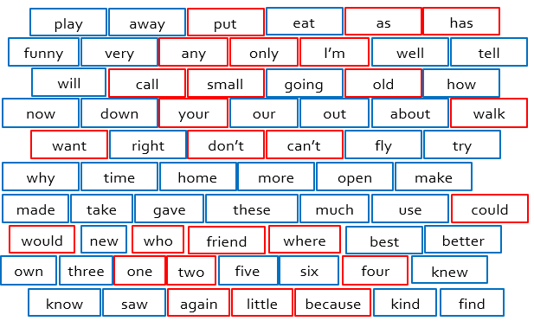

Stage 2

Stage 3

