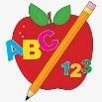 Primary 3 Homework 

**Week Beginning: 30th September 2024**

Here is a guide to help you for this week. You can choose how to organise your tasks to suit what works best for you.

|  |  |
| --- | --- |
| **Spelling** | **Numeracy** |
| Choose 2 activities from the spelling grid at the back of your jotter to practise your phoneme words and common words.   * Phoneme Words – a      * Common Words –   Please continue to practice spelling Stage 1 (Minions and Nemo) and Stage 2 (Shrek, Toy Story, and Lilo and Stitch) common words as well as new Stage 3 words. Stage 1 and 2 common words are attached below.  New common words this week:  second  fifteen  five  fourteen | Choose ‘mixed 1-100’ to practise finding one and ten more and less.  <https://www.topmarks.co.uk/learning-to-count/chopper-squad> |
| **Reading** |
| * Your child will get their book home to practise every Monday. * We will also be practising and completing activities in class so please remember to have their book in their bag every day. |
| **PE** |
| **P.E. is every Monday and Wednesdays.**  Please provide your child with a change of clothing and footwear as well as removing all piercings. **If your child has any stud earrings that they can’t**  **remove, with written permission, we can use plasters to cover them on gym days**. Remember your child can leave their PE kit in school which will be kept safely in the classroom. |

Stage 1

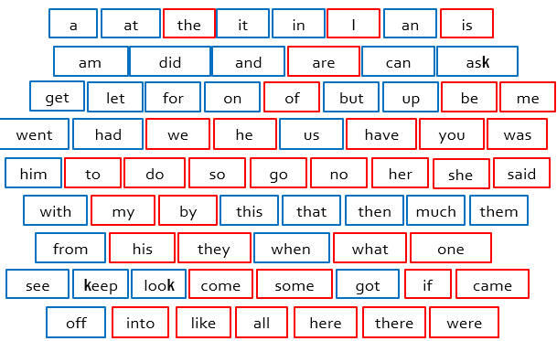

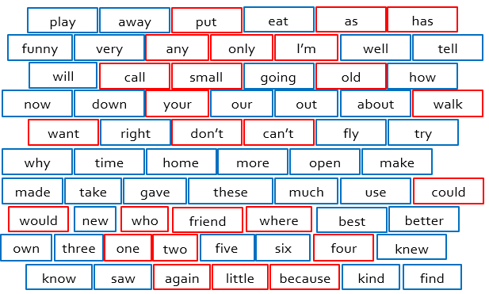 Stage 2