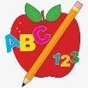 Primary 3 Homework 

**Week Beginning: 2nd September 2024**

Here is a guide to help you for this week. You can choose how to organise your tasks to suit what works best for you.

|  |  |
| --- | --- |
| **Spelling** | **Numeracy** |
| Choose 2 activities from the spelling grid below to practise your phoneme words and common words.   * Phoneme Words – Revision Week   Before we move on to learning our next phonemes, we are revising everything we learned in P2.  Write the words of the pictures below. Try to write at least 5 words in sentences.    *Minions and Nemo*  Write the words of the pictures below. Try to write at least 2 words in sentences.     * Common Words –   We will soon introduce new common words. Please continue to practice spelling Stage 1 (Minions and Nemo) and Stage 2 (Shrek, Toy Story, and Lilo and Stitch) common words for now. Stage 1 and 2 common words are attached below. | **Number Bonds to 20**  We are revising and practicing number bonds to 10 and 20. What is the highest score you can achieve in the time?  <https://www.topmarks.co.uk/maths-games/hit-the-button> |
| **Reading** |
| * Your child will get their book home to practise every Monday. * We will also be practising and completing activities in class so please remember to have their book in their bag every day. |
| **PE** |
| **P.E. is every Monday and Wednesdays.**  Please provide your child with a change of clothing and footwear as well as removing all piercings. **If your child has any stud earrings that they can’t**  **remove, with written permission, we can use plasters to cover them on gym days**. Remember your child can leave their PE kit in school which will be kept safely in the classroom. |

Stage 1

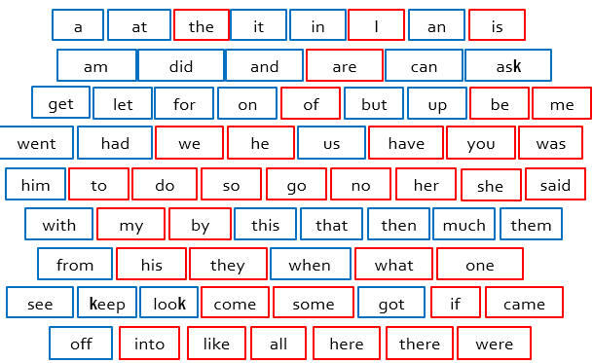

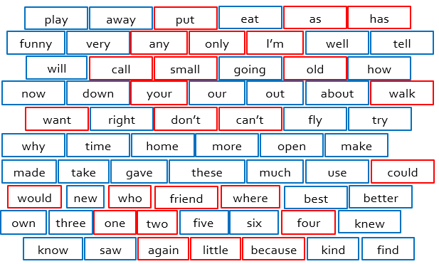 Stage 2