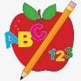 Primary 2 Homework
Week Beginning: 3rd June 2024
Here is a guide to help you for this week. You can choose how to organise your tasks to suit what works best for you.

Spelling | Numeracy
Choose 2 activities from the spelling grid below to practise your phoneme words and common words.  - Phoneme Words  Gruffalo, Stickman, Snail and the Whale i Zog wh  I when  hi what  kind whip  find whisk  mind whiskers  blind which  child whack  wild whizz  wind  pint  mild  Common Words  kind here  find there  - Word Wall –  When your child is able to read and spell a word on their word wall they can colour in that brick. This is an ongoing activity. | Use whatever you want to measure everyone in your family. You could use a fork, a pencil, or even the TV remote! Write down everyone’s height in your jotter. Who is the tallest? Who is the smallest? What is the difference between the tallest and smallest height?  Extra challenge: This game gives you some practice with measuring with a ruler in cms.  https://www.topmarks.co.uk/maths-games/measuring-in-cm
 | Reading
- Your child will get their book home to practise every Monday.
- We will also be practising and completing activities in class so please remember to have their book in their bag every day ©

 | Wednesday 5th June – Farm Park Trip
Remember we have a full school trip to the Farm Park on Wednesday. Please arrive at school on time, and bring a snack. Children should wear their school jumper, polo shirt or cardigan and jogging bottoms or leggings and sensible shoes or trainers. Please write your child’s name on the inside of their jumpers and trainers/shoes. This helps to prevent them from being lost when the children take them off for the bouncy pillow/soft play. Please be mindful of weather conditions and provide waterproofs or sun cream if required.
If you have asked for your child to have a school packed lunch, they will be provided with this. If not, please provide your child with a packed lunch to take on the trip.
P.E. is every Tuesday and Thursday.
Please provide your child with a change of clothing and footwear as well as removing all piercings. If your child has any stud earrings that they can’t
remove, with written permission, we can use plasters to cover them on gym days. Remember your child can leave their PE kit in school which will be
kept safely in the classroom.

First, write your spelling words in pencil. Then, use different coloured crayons to write your words 5 times by either tracing over the word each time or by writing them next to each other.

Upper and Lower
Write each of your spelling words two times. First, write each word in upper case letters. Then, write each word in lower CClSe letters.
p
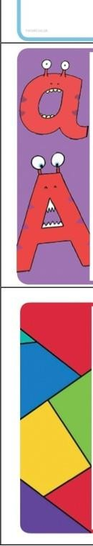
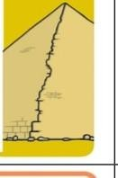
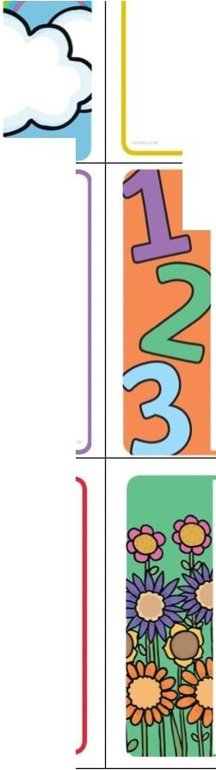
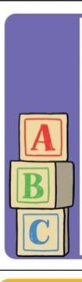
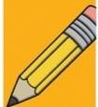
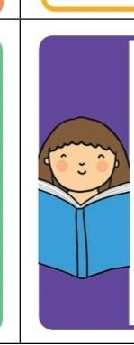
Pyramid write your spelling words.
Try to write them neatly!

Example:
50
som some

Three Times
Write each of your spelling words three times using a different coloured crayon or pen each time.

ABC Order
Write out your spelling words in alphabetical order.

cros ·c Poem
Choose one of your spelling words. Write on acrostic poem using that word.
Illustrate your poem.
Example: sun urnmer is here
oder the rays ewflowers grow

Silly Sentences
Write silly sentences with a spelling word in each sentence. Underline your spelling words.
Example:
My cat WtmS a ytllow hat whtn sht goc,dancing.

Blue Vowels
Write each of your spelling words. Trace the vowels in your words with a blue coloured pencil.

Vowels: a e i o u

Spelling Shapes
Count your spelling words. Draw one shape for each word. Now, write a spelling word in toch of tht shop,s.
Example: 880

Spelling Flowers
Draw a big flower. Write each of your spelling words on one of the petals.

Tell a Story
Write a story using all of your spelling words. Moh sure you underline your spelling words.

Bubble Words
Write your spelling words in bubble letters. A er you hove written them, you con colour them in with crayons.

