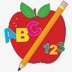 Primary 2 Homework
Week Beginning: 29th May 2024
Here is a guide to help you for this week. You can choose how to organise your tasks to suit what works best for you.

Spelling | Numeracy
We are not introducing a new phoneme this week due to only being in school 3 days, and Sports Day being on Friday. Please focus on revision of common words for spelling homework this week.  - Word Wall –  When your child is able to read and spell a word on their word wall they can colour in that brick. This is an ongoing activity. | 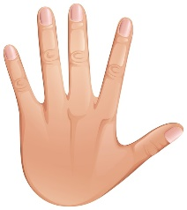  This week we are introducing measure. Measure objects around your house using your hands and feet.  For example, how many hand spans is your bed? What about your door?  How many of your feet is your kitchen?  Try to measure at least 5 things in your house.  Record your findings in your homework jotter.
 | Reading
- Children will be completing reading assessments in class this week, therefore Bug Club books will not be sent home.
- If you would like to practise reading with your child, choose a story to read from this website:
https://www.starfall.com/h/ltr-classic/?mg=m

 | Talking and Listening
- Your child will be presenting a show and tell to the class between Wednesday 29th and Thursday 30th May. Your child has prepared this presentation in class, and they will bring it home to practise.
- For this show and tell, they should bring in a special object which may relate to a hobby, interest or special memory. Please help them to choose an object which is not of extremely high value. Some ideas may include dancing shoes, a toy, a trophy or a photograph.
This week, PE will be on Wednesday.
Please provide your child with a change of clothing and footwear as well as removing all piercings. If your child has any stud earrings that they can’t
remove, with written permission, we can use plasters to cover them on gym days. Remember your child can leave their PE kit in school which will be
kept safely in the classroom.

First, write your spelling words in pencil. Then, use different coloured crayons to write your words 5 times by either tracing over the word each time or by writing them next to each other.

Upper and Lower
Write each of your spelling words two times. First, write each word in upper case letters. Then, write each word in lower CClSe letters.
p
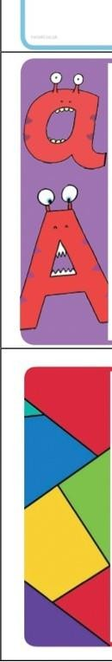
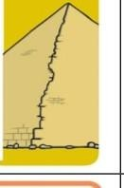
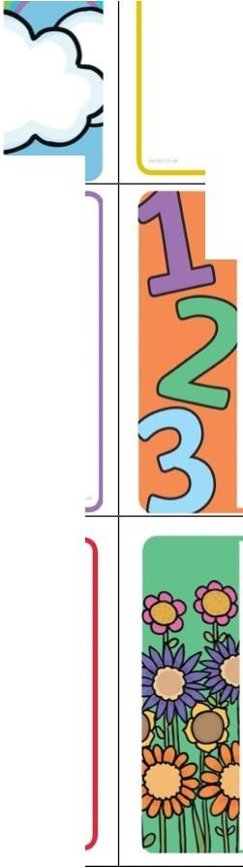
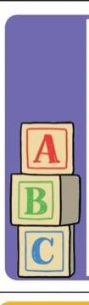
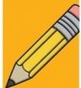
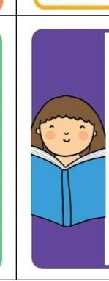
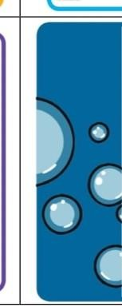
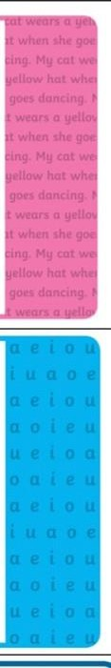
Pyramid write your spelling words.
Try to write them neatly!

Example:
50
som some

Three Times
Write each of your spelling words three times using a different coloured crayon or pen each time.

ABC Order
Write out your spelling words in alphabetical order.

cros ·c Poem
Choose one of your spelling words. Write on acrostic poem using that word.
Illustrate your poem.
Example: sun urnmer is here
oder the rays ewflowers grow

Silly Sentences
Write silly sentences with a spelling word in each sentence. Underline your spelling words.
Example:
My cat WtmS a ytllow hat whtn sht goc,dancing.

Blue Vowels
Write each of your spelling words. Trace the vowels in your words with a blue coloured pencil.

Vowels: a e i o u

Spelling Shapes
Count your spelling words. Draw one shape for each word. Now, write a spelling word in toch of tht shop,s.
Example: 880

Spelling Flowers
Draw a big flower. Write each of your spelling words on one of the petals.

Tell a Story
Write a story using all of your spelling words. Moh sure you underline your spelling words.

Bubble Words
Write your spelling words in bubble letters. A er you hove written them, you con colour them in with crayons.

