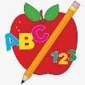 Primary 2 Homework
Week Beginning: 25th March 2024
Here is a guide to help you for this week. You can choose how to organise your tasks to suit what works best for you.

Spelling | Numeracy
- Choose 2 activities from the spelling grid below to practise your Phoneme words ©  - Common Words – revision week  Revising all common words taught so far.  Play the game on the back of this sheet.  For an extra challenge, read and write each word in your jotter.  - Word Wall –  When your child is able to read and spell a word on their word wall they can colour in that brick. This is an ongoing activity. | Division  Play Doggy Division sharing game.  https://ictgames.com/mobilePage/doggyDivision/index.html
 | Reading
- Your child will get their book home to practise every Monday.
- We will also be practising and completing activities in class so please remember to have their book in their bag every day.

P.E. is every Tuesday and Thursday ©
Please provide your child with a change of clothing and footwear as well as removing all piercings. If your child has any stud earrings that they can’t
remove, with written permission, we can use plasters to cover them on gym days. Remember your child can leave their PE kit in school which will be
kept safely in the classroom.

Remember to have lots of fun!

Common Words Snakes and Ladders
Roll the dice or use a number generator on your phone/tablet. Move your counter that many spaces along. Read the word you land on.

friend | where | new | true | when | what | then | FINISH
who | would | 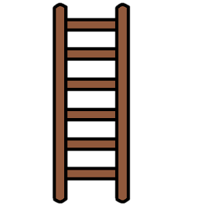  could | use | much | these | gave | take
try | why | time | home | more | open | make | made
fly | can’t | don’t | right | want | walk | about | out
small | going | old | how | now | down | your | our
call | will | tell | well | I’m | only | any | very
START | play | away | put | eat | where | has | funny

