Here is a guide to help you for this week. You can choose how to organise your tasks to suit what works for you.
 | Literacy | Numeracy
 | Spelling  Please copy these word 2 more times in your jotter. How you write them is up to you.  station nation shuffle  shoulder options brochure complications shoppers machine chef  quite quiet counting idea  they obey prey g grey trolley monkey money honey survey convey  read call even close  cow now row  owl down town allow growl brown frown  how shower where too  Phil phone phonics  phoneme trophy dolphin  elephant phantom alphabet photograph one first little of | Click on the Learning Intention to play the games.  (You might need to hold ctrl and click)  LI – We are revising our 2x, 5x and 10x tables and learning the 4x table.  LI – We are revising our 2x, 5x and 10x tables and learning the 4x table.  LI – We are learning to divide by 2 mentally.
 | 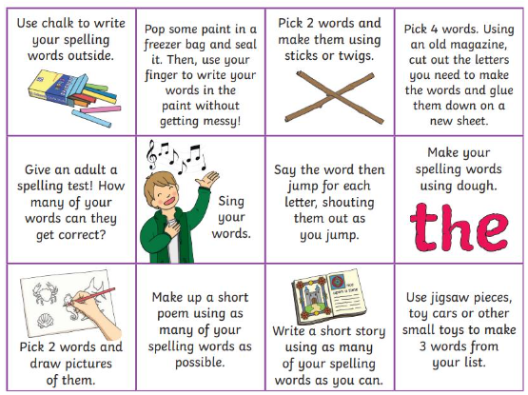  Then please choose one of the activities from the spelling menu to learn your words. | Reading  LI – We are learning to be fluent readers with expression.  How to be a Sports Star  Planet Earth  Sports Day Snack Attack  Epic Adventures  Our Camping Trip
Please bring book folders to school every day. They will be collected in on Friday. If your feel you want to continue some of the homework over the weekend please ask for your child’s book folder.
Remember to have lots of fun!

