Here is a guide to help you for this week. You can choose how to organise your tasks to suit what works for you.
Friday 15th March @ 2pm
 | Literacy | Numeracy
 | Spelling  Please copy these word 2 more times in your jotter. How you write them is up to you.  shouted shoe lotion  potion quiche crochet  mansion pension emotion shower  fruit believe decided another  you your could g would should group youth mousse routine coupon  open song hard might  flew stew grew  drew few new crew jewel knew Lewis  what many soon book  what wheel whip  when why whisk  whale whistle whisker whisper do out now new | Click on the Learning Intention to play the games.  (You might need to hold ctrl and click)  LI – We are revising our 2x, 5x and 10x tables and learning the 4x table.  LI – We are revising our 2x, 5x and 10x tables and learning the 4x table.  LI – We are learning to divide by 2 mentally.
 | 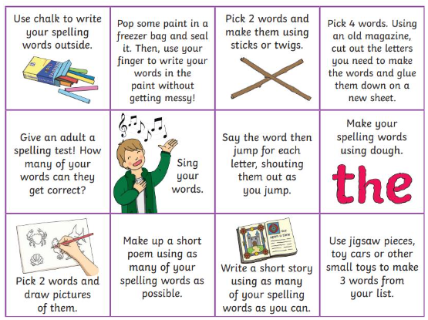  Then please choose one of the activities from the spelling menu to learn your words. | Reading  LI – We are learning to be fluent readers with expression. *ASSEMBLY LINES*  Double Trouble  Lickety Kwick and the Mixed-up Fix  Fossils  Wallace & Gromit and the Soccamatic  What do you want that for?
Please bring book folders to school every day. They will be collected in on Friday. If your feel you want to continue some of the homework over the weekend please ask for your child’s book folder.
Remember to have lots of fun!

