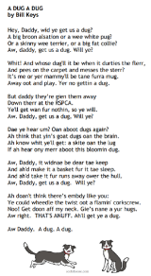
Here is a guide to help you for this week. You can choose how to organise your tasks to suit what works for you.
Dress to Express Friday 2nd February
 | Literacy | Numeracy
 | Spelling  Please copy these word 2 more times in your jotter. How you write them is up to you.  tortoise porpoise rejoice  turquoise joystick royalty loyal annoy annoying avoid  May June July August  character chorus chemist g Christmas chord ache headache anchor architect school  any carry along story  blue glue true  clue Sue issue cruel tissue due argue  best number other have  ship shop shed  shut sharp ash  mash dish flash fresh  she come from we | Click on the Learning Intention to play the games.  (You might need to hold ctrl and click)  LI – We are revising our 2x, 5x and 10x tables and learning the 4x table.  LI – We are revising our 2x, 5x and 10x tables and learning the 4x table.  LI – We are finding the area in square units.  WARNING – this game has sound!
 | 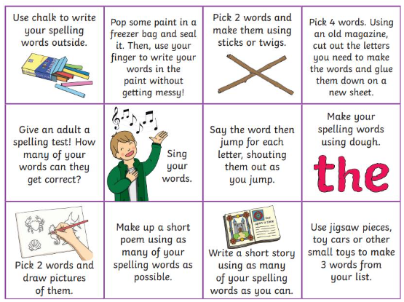  Then please choose one of the activities from the spelling menu to learn your words. | Reading  LI – We are learning to be fluent readers with expression.  About Earth  Awesome Animal Adventures  Chocolate!  Zoo Map  Whose Footprints?
Please bring book folders to school every day. They will be collected in on Friday. If your feel you want to continue some of the homework over the weekend please ask for your child’s book folder.
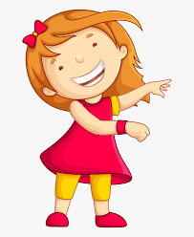Remember to have lots of fun!

