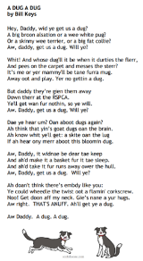
Here is a guide to help you for this week. You can choose how to organise your tasks to suit what works for you.
Scots Poem “A Dug A Dug” (paper copy in bag)
 | Literacy | Numeracy
 | Spelling  Please copy these word 2 more times in your jotter. How you write them is up to you.  after safe family  traffic offer daffodil phonics telephone elephant photocopy  square triangle rectangle different  have leave believe  retrieve starve relieve  love glove receive  own live give something  tea speak clean  steal team stream  wheat steam treat clear  ask each year eat  we me he  she be bed  wed fed red ted  with his her the | Click on the Learning Intention to play the games.  (You might need to hold ctrl and click)  LI – We are revising our 2x and 5x tables and learning the 4x table.  LI – We are revising our 2x, 5x and 10x tables and learning the 4x table.  LI – We are reading and matching times with 5 minute intervals.  WARNING – this game has sound!
 | 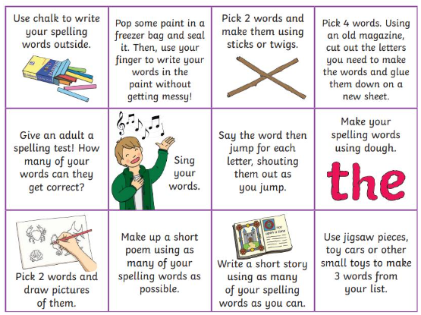  Then please choose one of the activities from the spelling menu to learn your words. | Reading  LI – We are learning to be fluent readers.  Mae in the Middle: Super Sleuth  Meddlers: Tick, Tock, Unfix the Clock  Pirates Life at Sea  Wallace & Gromit and the Snowman-o-tron  Stuck in the Mud
Please bring book folders to school every day. They will be collected in on Friday. If your feel you want to continue some of the homework over the weekend please ask for your child’s book folder.
Remember to have lots of fun!

