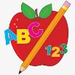 Primary 4 Homework
Week Beginning: 9th October 2023
Here is a guide to help you for this week. You can choose how to organise your tasks to suit what works for you.
 | Literacy | Numeracy
 | Spelling  Please copy these word 2 more times in your jotter. How you write them is up to you.  between feelings cheat  speak he she  thief mischief complete evening  football group holiday I’m  came take gave  cute huge rude  seat read team speak  each year away always  Phil phone photo  phonics graph orphan  trophy dolphin elephant alphabet  one first little of | Click on the Learning Intention to play the games.  (You might need to hold ctrl and click)  LI – We are revising our 2x and 5x tables.  LI – We are reading and matching times with 5 minute intervals.  WARNING – this game has sound!
 | 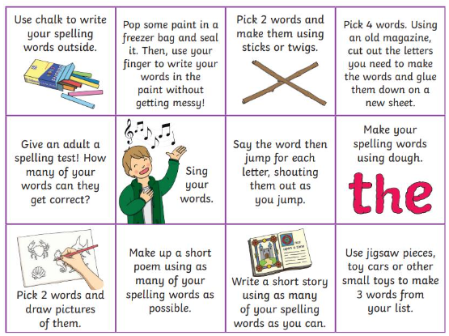  Then please choose one of the activities from the spelling menu to learn your words. | Reading  LI – We are learning to be fluent readers.  The Great Getaway  Superpet!  All About Mummies  The Mermaids and the Perfect  Presents  Stop. Look and Listen
Please bring book folders to school every day. They will be collected in on Friday. If your feel you want to continue some of the homework over the weekend please ask for your child’s book folder.

Remember to have lots of fun!

