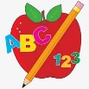 Primary 4 Homework
Week Beginning: 2nd October 2023
Here is a guide to help you for this week. You can choose how to organise your tasks to suit what works for you.
 | Literacy | Numeracy
 | Spelling  Please copy these word 2 more times in your jotter. Use  indeed agree please  leave me we  believe piece these here  bike five hide  beside home phone  before here evening complete  why what when  where whale wheel  while whisk whisper whiskers | Click on the Learning Intention to play the games.  (You might need to hold ctrl and click)  LI – We are revising our 2x table.  LI – We are revising our skills in matching o’clock, half past, quarter past and quarter to times.  WARNING – this game has sound!
 | 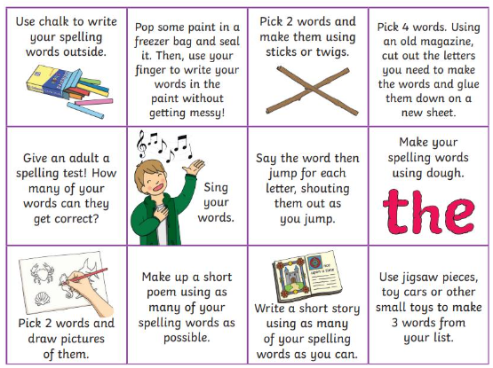  Then please choose one of the activities from the spelling menu to learn your words. | Reading  LI – We are learning to be fluent readers.  Wizards, Spiders and Castles  Blood Buns and Scarecrows  Marion to the Rescue  Martial Arts  Answer the Phone Fiona!
Please bring book folders to school every day. They will be collected in on Friday. If your feel you want to continue some of the homework over the weekend please ask for your child’s book folder.
Remember to have lots of fun!

