**P4 Homework Activities**

**Week Beginning: 7th October 2024**

**Monday – Thursday** 

Try to work on some homework tasks each night. You can fit them in around your family schedule. Return your jotters to school on **Thursday 10th October.**

**SPELLING : Common Words**

**Spelling Test in class for this week’s spelling words.**

|  |  |  |
| --- | --- | --- |
| **Emerald** | **Ruby** | **Diamond/ Sapphire** |
|  |  |  |
| **difficult**  **decide**  **Drongan**  **Dundee**  **suddenly**  **oddly**  **saddest**  **decided**  **followed**  **cuddled** | **dance**  **dropped**  **does**  **doesn’t**  **middle**  **adding**  **ladder**  **looked**  **tired**  **scared** | **tried**  **pie**  **fried**  **lied**  **magpie**  **replied**  **lie**  **fries**  **dried**  **tie** |

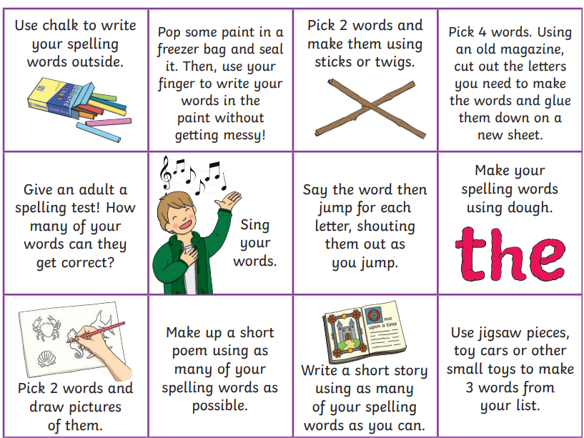

* Write a sentence for each word.
* Choose some activities from the grid above to learn them for your spelling test on Friday.

**READING & COMPREHENSION**

BugClub-read and complete the allocated class book.

**Lions – Rocky and the Wolf Cub**

**Elephants – All at Sea**

**Monkeys – What’s Out There?**

**Giraffes – Epic Adventures**

**Hippos – Rat and Cat in the Dance**

**NUMERACY**

Practise your times tables using the games below:

* <https://www.topmarks.co.uk/maths-games/mental-maths-train>
* <https://phet.colorado.edu/sims/html/arithmetic/latest/arithmetic_en.html>

**Topic – The Rainforest**

The children are learning about “The Rainforest” and will present an assembly on the 28th of November telling you what they have learnt. As a coopereative homework task I have asked the children to make a rainforest in a shoe box, your help with this would be greatly appreciated. We have talked through the different examples below and have agreed that everybody will try their best to complete this by the 21st of November so that they can be used in our class assembly.

