**P4 Homework Activities**

**Week Beginning: 2nd September 2024**

**Monday – Thursday** 

Try to work on some homework tasks each night. You can fit them in around your family schedule. Return your jotters to school on a Thursday**.**

**SPELLING : Common Words**

**Spelling Test in class for this week’s spelling words.**

|  |  |  |
| --- | --- | --- |
| **Emerald** | **Ruby** | **Diamond/ Sapphire** |
|  |  |  |
| **downstairs**  **explain**  **complain**  **blame**  **fame**  **chase**  **replay**  **betray**  **anyway**  **Ayrshire** | **afraid**  **Airport**  **wait**  **space**  **place**  **age**  **pray**  **delay**  **payment**  **Ayr** | **wrist**  **wrong**  **wren**  **wrist**  **wrap**  **wrapper**  **written**  **write**  **wriggle**  **unwrap** |

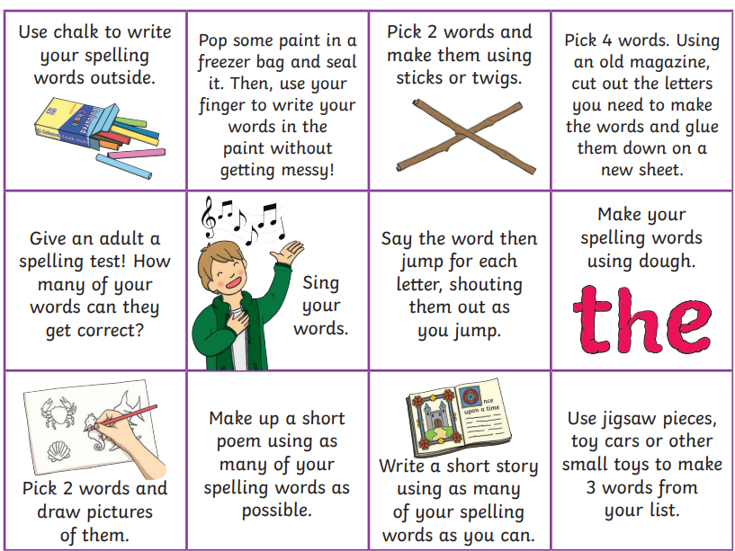

* Write a sentence for each word.
* Choose some activities from the grid about to learn them for your spelling test on Friday.

**READING & COMPREHENSION**

BugClub-read and complete the allocated class book.

**Lions - Mae in Middle Music Master**

**Elephants - Super Pets**

**Monkeys - Pete’s Peculiar Pet Shop Just the Job**

**Giraffes – Horribilly Gloopy Food**

**Hippos - King Pip and the Dark Forest**

**NUMERACY**

We are learning about place value. Please see some games below. Work your way through the levels to see how far you can challenge yourself.

* <https://www.topmarks.co.uk/maths-games/rocket-rounding>
* <https://www.topmarks.co.uk/learning-to-count/place-value-basketball>