P5B Homework Activities
Week Beginning: 04/12/23
School Christmas Fayre- Tuesday 5th- Main Hall- 6.30 pm
Panto - Wednesday 6th at Ayr Gaiety Theatre. Children can bring a small snack and drink.
Christmas Lunch -Thursday 7th.
Monday – Thursday
Try to work on some homework tasks each night. You can fit them in around your family schedule. Return your jotters to school on a Friday please.
Literacy : Use this picture to write a descriptive paragraph.
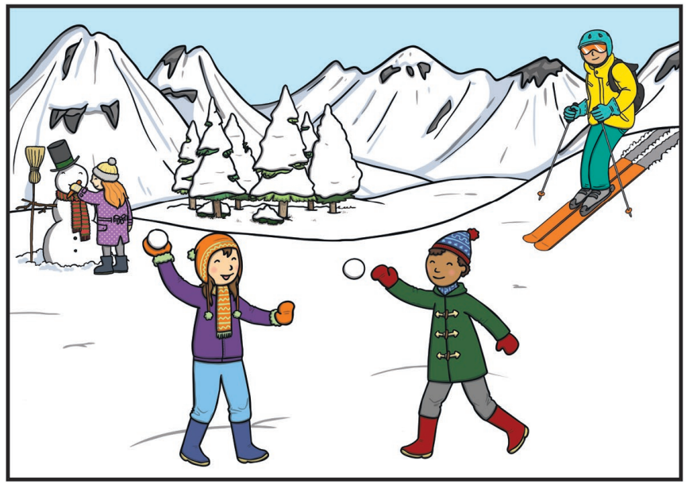 ***********************************************************************************
READING & COMPREHENSION
BugClub-read and complete the allocated class book.
Roald Dahls – Everyone Loves King Julien
David Walliams – Sports Day Snack Attack
J.K Rowling – 101 Ways to Save the Planet before Bedtime

****************************************************************************************************

NUMERACY
Use the multiplication table and link to this game and songs to practice your times tables for your Ninja Challenge.
https://www.timestables.co.uk/games/ You can practice on this too.

https://www.youtube.com/watch?v=oPINS56lDes Multiplication Songs for Children (Official Video) Multiply Numbers 1 through 12 for Kids

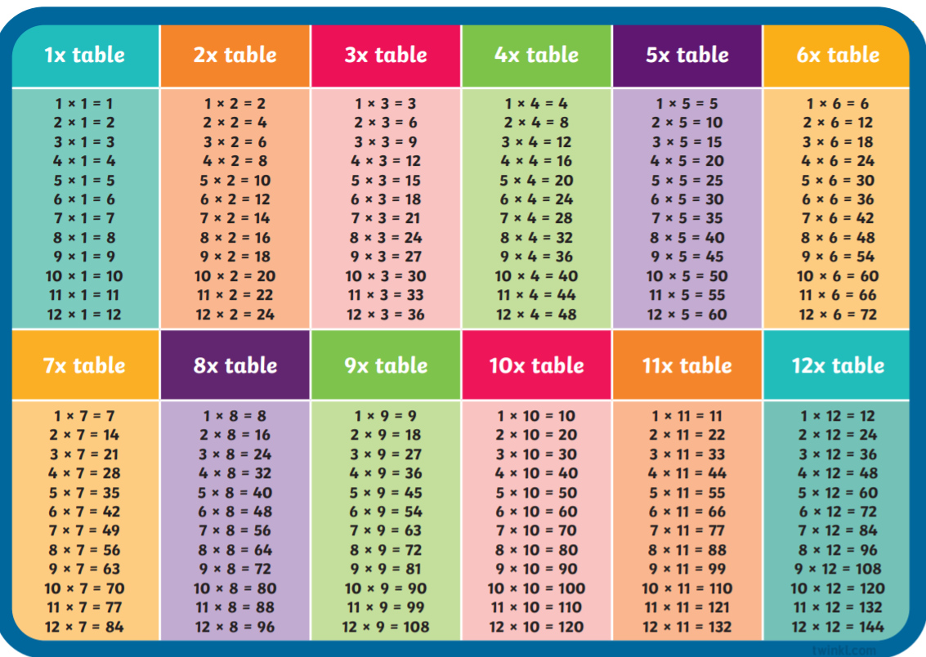
Check out these websites for some other activities you could try out throughout the session.
https://www.coolmathgames.com/
https://www.topmarks.co.uk/
https://www.worldofdavidwalliams.com/
https://www.bbc.co.uk/bitesize

