P5B Homework Activities
Week Beginning: 13/11/23
Monday – Thursday
Try to work on some homework tasks each night. You can fit them in around your family schedule. Return your jotters to school on a Friday please.
Children In Need Day- Friday 17th November.
SPELLING :
Spelling Test in class for this week’s spelling words.
Group 1 | Group 2 | Group 3
- waterproof  - swooping  - schoolbag  - prune  - flute  - stewing/  - threw  - continue  - statue  - cuboid | - shook  - school  - tooth  - cute  - fuse  - blew  - chew  - glue  - rescue  - push | - knot  - knit  - knap  - kneel  - knock  - shook  - tooth  - tool  - zoo  - spoon

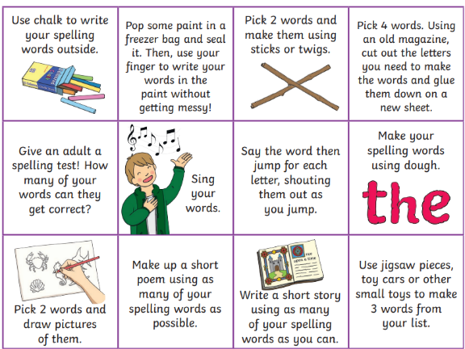
- Look at the spelling words for your group, copy each word 3 times.
- choose some activities from your spelling menu to learn them .
- Try to do at least 3 different activities from the list, but you can do more to challenge yourself !

READING & COMPREHENSION
BugClub-read and complete the allocated class book.
J.K Rowlings – The Charlie Small Journals: Gorillas vs The Leopard Men
David Walliams – Flint the Inventor
Roald Dahls -

NUMERACY
Test your data handling skills with this game. It can be accessed via the qr code or the link.
https://mathsframe.co.uk/en/resources/resource/51/bar_charts
Use the multiplication table and link to this game and songs to practice your times tables for your Ninja Challenge.
https://www.timestables.co.uk/games/ You can practice on this too.

https://www.youtube.com/watch?v=oPINS56lDes Multiplication Songs for Children (Official Video) Multiply Numbers 1 through 12 for Kids

