P5B Homework Activities
Week Beginning: 23/10/23
Monday – Thursday
Try to work on some homework tasks each night. You can fit them in around your family schedule. Return your jotters to school on a Friday please.
SPELLING :
Spelling Test in class for this week’s spelling words.
Cast-a-spell | Punktuators | Word Busters
happy  word  lady  paper  window  floor  shoe  being  coming  jumped  started  used  walked  woke  only | accident  below  cloudy  eleven  football  group  holiday  I’m  I’ve  playtime  practising  whispered  emotion  knew  biscuit | each  ask  year  eat  yellow  grow  again  food  blue  best  number  other  very  took  fast

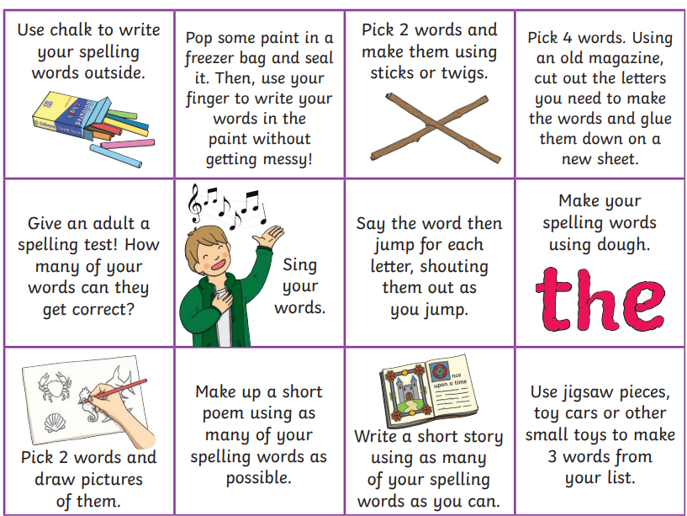
- Look at the spelling words for your group, copy each word 3 times.
- Choose some activities from your spelling menu to learn them .
- Try to do at least 3 different activities from the list, but you can do more to challenge yourself !
READING & COMPREHENSION
BugClub-read and complete the allocated class book.
J.K Rowling’s – How to be an Explorer
David Walliams’ – Thunderbirds are Go – Tunnels of Time
Roald Dahl’s – Birthdays around the World
NUMERACY
Use this game to generate column addition calculations. Complete them in your jotter for your teacher to see.
https://www.mathmammoth.com/practice/vertical-addition
Use the multiplication table and link to this game and songs to practice your times tables for your Ninja Challenge.
https://www.timestables.co.uk/games/ You can practice on this too.

https://www.youtube.com/watch?v=oPINS56lDes Multiplication Songs for Children (Official Video) Multiply Numbers 1 through 12 for Kids

