P5B Homework Activities
Week Beginning: 02/10/23
Monday – Thursday
Try to work on some homework tasks each night. You can fit them in around your family schedule. Return your jotters to school on a Friday please.
SPELLING :
Spelling Test in class for this week’s spelling words.
Cast-a-spell | Punktuators | Word Busters
eighteen  unspeakable  fieldmouse  incomplete  weekend  teamwork  weakness  mischievous  these  unbelieveable | agree  street  three  read  leaf  field  piece  here  these  plea | see  tree  green  free  bee  sight  fright  might  light  right

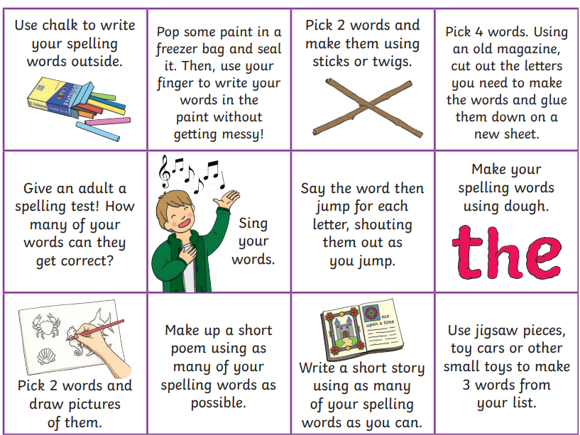
- Look at the spelling words for your group, copy each word 3 times.
- choose some activities from your spelling menu to learn them .
- Try to do at least 3 different activities from the list, but you can do more to challenge yourself !

READING & COMPREHENSION
BugClub-read and complete the allocated class book.
J.K Rowling’s – Buried Treasure
David Walliams’ – Chocolate
Roald Dahl’s – Amazing Trees
NUMERACY
Check out these Subtraction Videos.
https://watchkin.com/a6786c9c10 Subtraction TU
https://watchkin.com/f3733d010d Subtraction HTU

Use the multiplication table and link to this game and songs to practice your times tables for your Ninja Challenge.
https://www.timestables.co.uk/games/ You can practice on this too.

https://www.youtube.com/watch?v=oPINS56lDes Multiplication Songs for Children (Official Video) Multiply Numbers 1 through 12 for Kids

