P5B Homework Activities
Week Beginning: 18/09/23
Monday – Thursday
Try to work on some homework tasks each night. You can fit them in around your family schedule. Return your jotters to school on a Friday the 22nd.
SPELLING : Common Words
Spelling Test in class for this week’s spelling words.
Cast a Spell | Punktuators | Word Busters
shoulder  they  called  round  continue  previous  morning  allow  our  asked  state  weather  who  where  what | above  breakfast  cupboard  eight  eighteen  experiment  first  hear  listen  nine  nineteen  million  surprise  care  busy | have  your  only  by  are  come  of  new  said  could  her  before  day  away  today

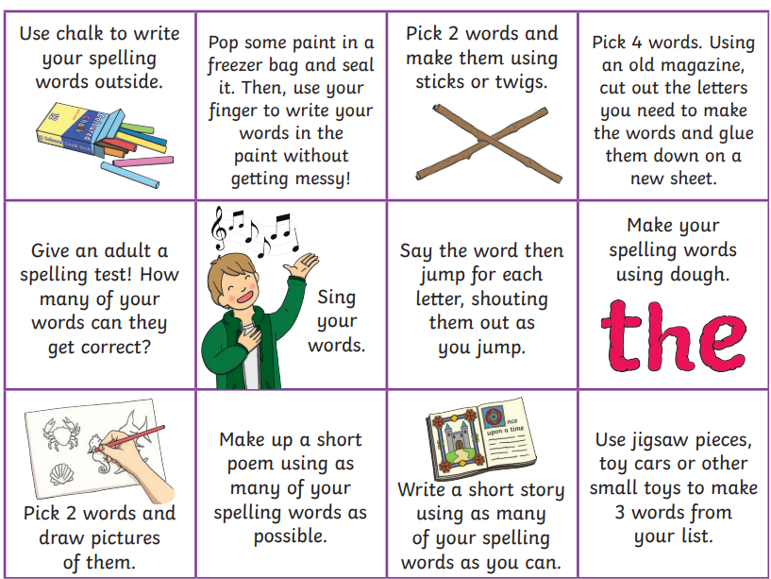
- Look at the spelling words for your group, copy each word 3 times.
- Choose some activities from your spelling menu to learn them.

READING & COMPREHENSION
BugClub-read and complete the allocated class book.
J.K. Rowlings - Beowulf and the Beast
David Walliams – Best Birthday Ever
Roald Dahls – Brave the Waves
NUMERACY
We have been learning about place value and addition. Please see some games below. Work your way through the levels to see how far you can challenge yourself.
- https://www.topmarks.co.uk/maths-games/hit-the-button - addition, multiplication
- https://www.topmarks.co.uk/maths-games/rocket-rounding
- https://www.topmarks.co.uk/maths-games/daily10 - addition, rounding

