P5B Homework Activities
Week Beginning: 11/09/23
Monday – Thursday
Try to work on some homework tasks each night. You can fit them in around your family schedule. Return your jotters to school on a Friday please.
SPELLING : Phoneme -ae
Spelling Test in class for this week’s spelling words.
Group 1 | Group 2 | Group 3
ey ea | ey ea | ou
chimney  turkey  honey  honeycomb  valley  breakfast  greatest  steaks  breaking  daybreak | they  obey  money  honey  monkey  break  breaking  great  greater  steak | face  rage  date  take  gave  round  found  pound  ground  loud

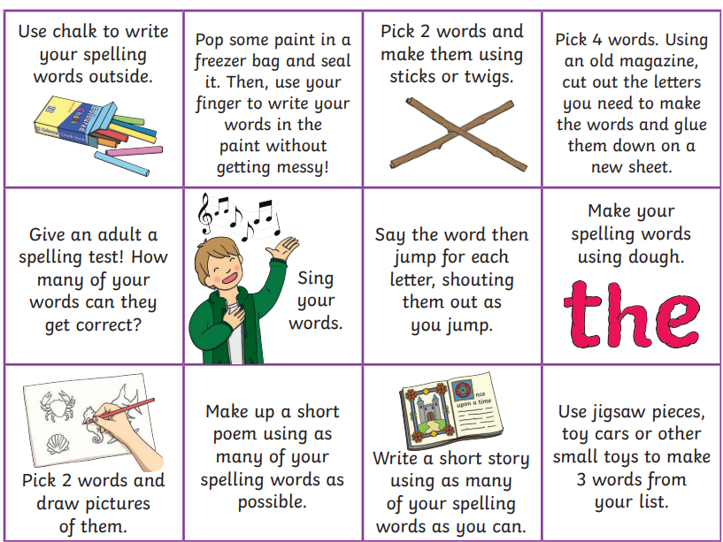
- Look at the spelling words for your group, copy each word 3 times.
- Choose some activities from your spelling menu to learn them.

READING & COMPREHENSION
BugClub-read and complete the allocated class book.
J.K. Rowlings - Beowulf and the Beast
David Walliams – Best Birthday Ever
Roald Dahls – Slow and Sticky

NUMERACY
Use the multiplication table and link to this game and songs to practice your times tables for your Ninja Challenge.
https://www.timestables.co.uk/games/ You can practice on this too.

https://www.youtube.com/watch?v=oPINS56lDes Multiplication Songs for Children (Official Video) Multiply Numbers 1 through 12 for Kids

