P5B Homework Activities
Week Beginning: 04/09/23
Monday – Thursday
Try to work on some homework tasks each night. You can fit them in around your family schedule. Return your jotters to school on a Friday please.
SPELLING : Phoneme -ae
Spelling Test in class for this week’s spelling words.
Group 1 | Group 2 | Group 3
a-e ay ai | a-e ay ai | a-e ou
chocolate  mistake  amazed  holidaying  birthdays  yesterday  downstairs  explaining  complaining  unafraid | chocolate  mistake  amazed  holidaying  birthdays  yesterday  downstairs  explaining  complaining  unafraid | face  rage  date  take  gave  round  found  pound  ground  loud

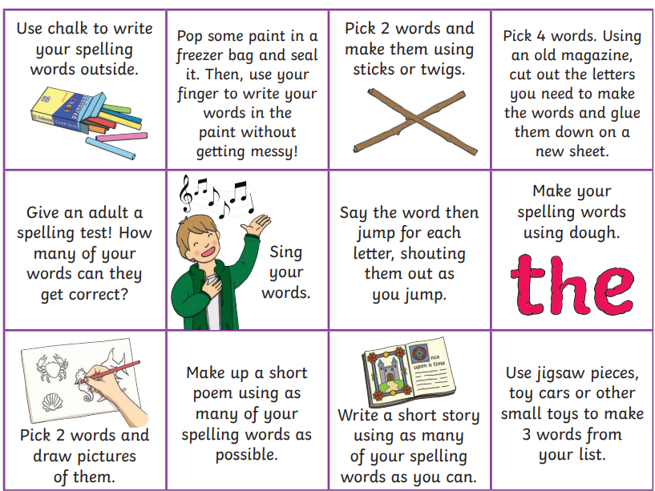
- Look at the spelling words for your group, choose some activities from your spelling menu to learn them .
- Try to do at least 3 different activities from the list, but you can do more to challenge yourself !

READING & COMPREHENSION
BugClub-read and complete the allocated class book.
Group 1 – Heading for Glory
Group 2 – The Great Escape
Group 3 – Wallace and Gromit and the Snowman-o-tron

NUMERACY
Use the multiplication table and link to this game and songs to practice your times tables for your Ninja Challenge.
https://www.timestables.co.uk/games/ You can practice on this too.

https://www.youtube.com/watch?v=oPINS56lDes Multiplication Songs for Children (Official Video) Multiply Numbers 1 through 12 for Kids

