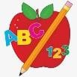 Primary 3 Homework
Spelling | Numeracy
Copy your words three times and write 2-3 sentences.  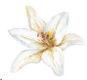        Continue to practice your common words at home! This will help a lot with reading and spelling | Please click the link to take you to game.  We are revising some of our math topics:  We are learning about place value.  We are learning to round numbers to the nearest 10.  Children have their Nessy logins in their bag, log in and have a go at the Nessy Numeracy-  Nessy
  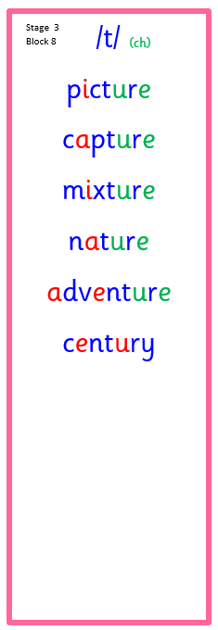 | 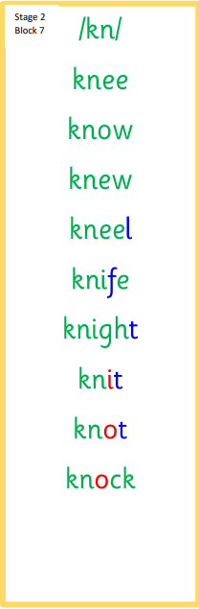 |   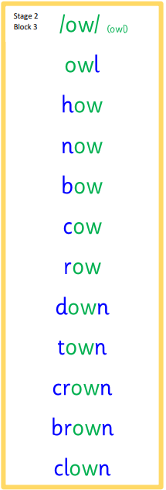 | 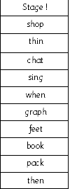
 | Reading
- Your child will get their book home to practice every Monday.
- We will also be practicing and completing activities in class so please remember to have their book in their bag every day.
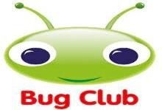

 | PE
P.E. is every Tuesday and Thursday.
Please provide your child with a change of clothing and footwear as well as removing all piercings. If your child has any stud earrings that they can’t
remove, with written permission, we can use plasters to cover them on gym days. Remember your child can leave their PE kit in school which will be kept safely in the classroom.
Week Beginning: 27th April 2026
Here is a guide to help you for this week. You can choose how to organise your tasks to suit what works best for you.

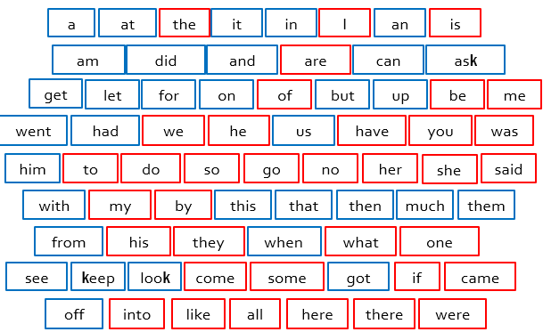
Stage 1

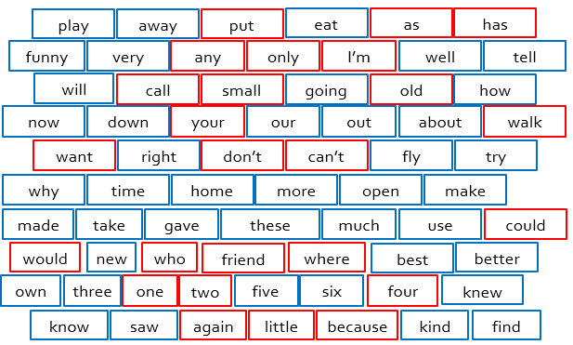
Stage 2

Stage 3
