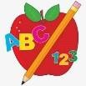 Primary 3 Homework
Spelling | Numeracy
Copy your words three times and write 2-3 sentences.    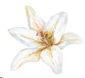    Continue to practice your common words at home! This will help a lot with reading and spelling | Please click the link to take you to game.  LI- We are learning to double numbers.  Diamonds LI- We are learning to halve numbers  Circles, Triangles and Squares LI- We are learning to halve numbers.
  
    tch, se, ve
    catch
    watch
    match
    nurse
    house
    please
    noise
    have
    leave
    live
    tch, se, ve
    catch
    watch
    match
    nurse
    house
    please
    noise
    have
    leave
    live
    ou, ow, oi
    our
    about
    now
    down
    round
    mouth
    spoil
    join
    point
    toilet
    ph, ee, oo
    phone
    graph
    cheese
    green
    been
    dolphin
    moon
    soon
    took
    book
 | Reading
- Your child will get their book home to practice every Monday.
- We will also be practicing and completing activities in class so please remember to have their book in their bag every day.


 | PE
P.E. is every Tuesday and Thursday.
Please provide your child with a change of clothing and footwear as well as removing all piercings. If your child has any stud earrings that they can’t
remove, with written permission, we can use plasters to cover them on gym days. Remember your child can leave their PE kit in school which will be kept safely in the classroom.
Week Beginning: 24th November 2025
Here is a guide to help you for this week. You can choose how to organise your tasks to suit what works best for you.

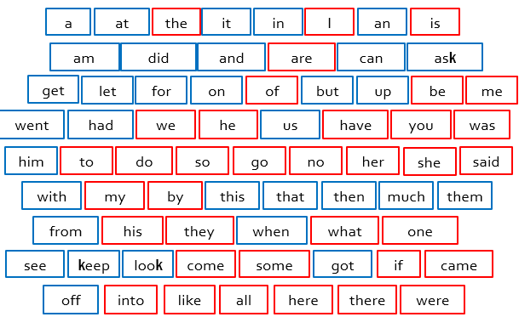
Stage 1

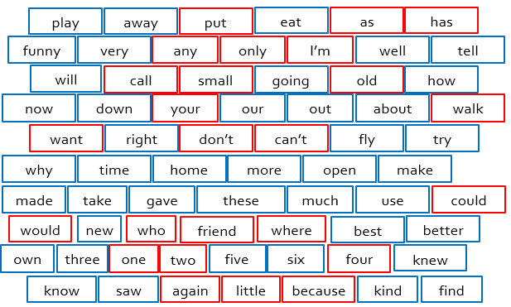
Stage 2

Stage 3
