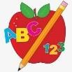 Primary 3 Homework
Week Beginning: 8th September 2025
Here is a guide to help you for this week. You can choose how to organise your tasks to suit what works best for you.

Spelling | Numeracy
Tulips  We are practicing the sound th. Please write your spelling words into your homework jotter and write 1 sentence using at least 1 of your spelling words.  Lilies  We are practicing the sound th. Please write your spelling words into your homework jotter and write 2 sentences using your spelling words.  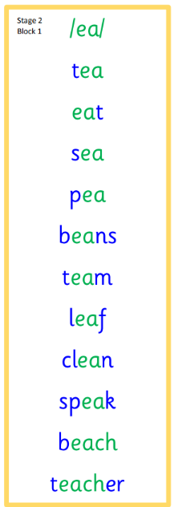  Roses and Daisies  We are practicing the sound w(a). Please write your spelling words into your homework jotter and write 3 sentences using your spelling words.  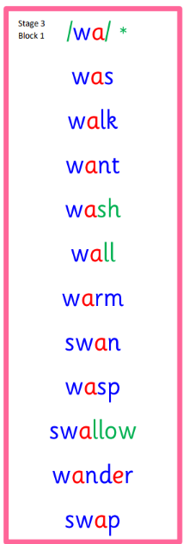  - Common Words –  Continue to read common words for practice for all of your reading. Please find attached below the list of stage 1, stage 2 and stage 3 common words. | Click the link below to take you to the games.  LI- We are learning the value of 2 and 3-digit numbers.  LI- We are learning our odd and even numbers.- we have been discussing odd Todd and even Steven to help us remember what numbers are odd and even.
 | Reading
- Your child will get their book home to practise every Monday.
- We will also be practicing and completing activities in class so please remember to have their book in their bag every day.


 | PE
P.E. is every Tuesday and Thursday.
Please provide your child with a change of clothing and footwear as well as removing all piercings. If your child has any stud earrings that they can’t
remove, with written permission, we can use plasters to cover them on gym days. Remember your child can leave their PE kit in school which will be kept safely in the classroom.

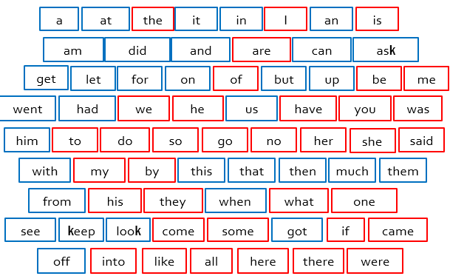
Stage 1

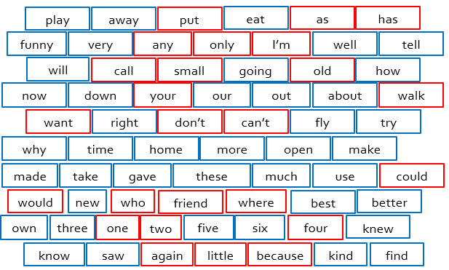
Stage 2

Stage 3
