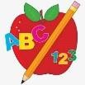 Primary 3 Homework
Week Beginning: 8th September 2025
Here is a guide to help you for this week. You can choose how to organise your tasks to suit what works best for you.

Spelling | Numeracy
Tulips  We are practicing the sound th. Please write your spelling words into your homework jotter and write 1 sentence using at least 1 of your spelling words.    Lilies  We are practicing the sound th. Please write your spelling words into your homework jotter and write 2 sentences using your spelling words.  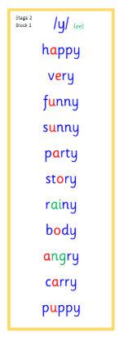  Roses and Daisies  We are practicing the sound w(a). Please write your spelling words into your homework jotter and write 3 sentences using your spelling words.  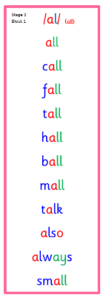  - Common Words –  Stage 1  This  That  Then  Much  Them  Stage 2  Funny  Very  Any  Only  Stage 3  Call  Fall  Talk  Also  Continue to read common words for practice for all of your reading. Please find attached below the list of stage 1, stage 2 and stage 3 common words. | We are learning to count in 2s, 5s, 10s.  We have been learning a song about counting in 5’s by Taylor Swift, please find song link and lyrics attached below-  https://www.youtube.com/watch?v=fY4h0kMbiKQ&list=RDfY4h0kMbiKQ&start_radio=1- start at 50 seconds.  Lyrics-  We start with 5, 10, 15, 20 +5,  Move on to 30.  Next comes 35.  We go to 40.  45 comes back every time.  We’re learning to count by 5’s (x2)  You got that 50.  Don’t forget 55.  And I got that 60.  What’s next? Oh yeah 65!  Keep adding on 5.  I promise you’re doing just fine.  We’re learning to count by 5’s (x2).  LI- We're learning to count forwards and backwards by 5s.- see how many pizza’s you can collect and write down in your jotter.  LI- We're learning to count fowards and backwards in 2s. – keep a note of your score in your jotter.
 | Reading
- Your child will get their book home to practise every Monday.
- We will also be practicing and completing activities in class so please remember to have their book in their bag every day.


 | PE
P.E. is every Tuesday and Thursday.
Please provide your child with a change of clothing and footwear as well as removing all piercings. If your child has any stud earrings that they can’t
remove, with written permission, we can use plasters to cover them on gym days. Remember your child can leave their PE kit in school which will be kept safely in the classroom.

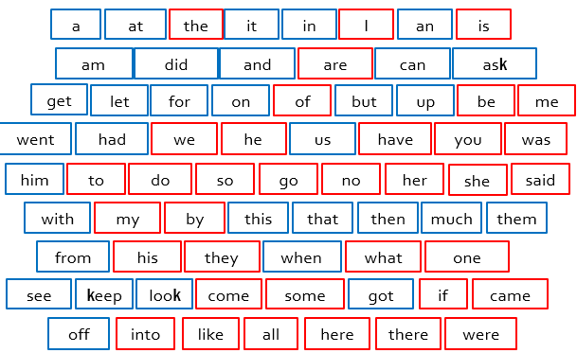
Stage 1

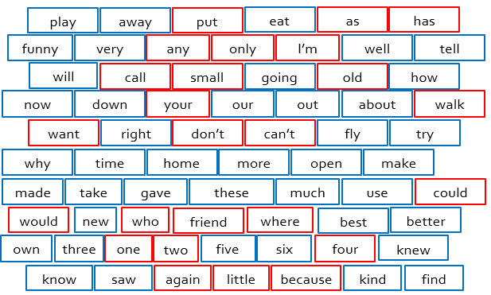
Stage 2

Stage 3
